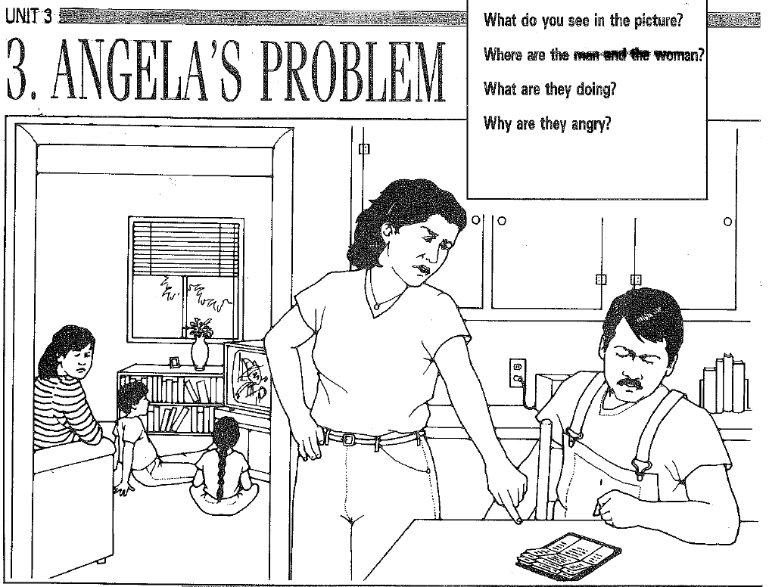
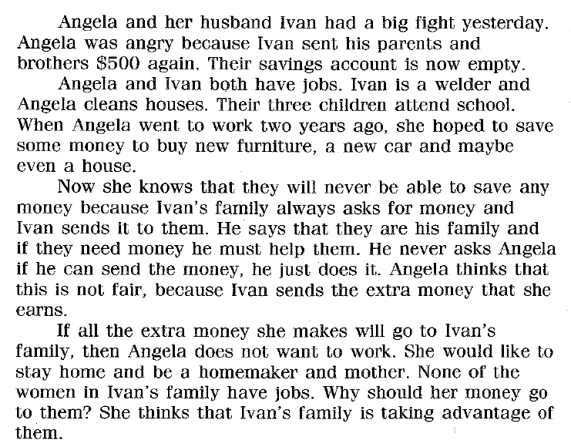
Comprehension Questions – Write your answer.
- What did Angela and Ivan do yesterday?

- Why was Angela angry with Ivan?

- Has Ivan ever sent money without asking Angela before?

- What would Angela like to do with extra money they have?

- Do you think it’s a good idea for Ivan to send money to his family without talking to Angela about it first? Why or why not?

Talk about these questions with your classmates, then discuss some of them as a class.
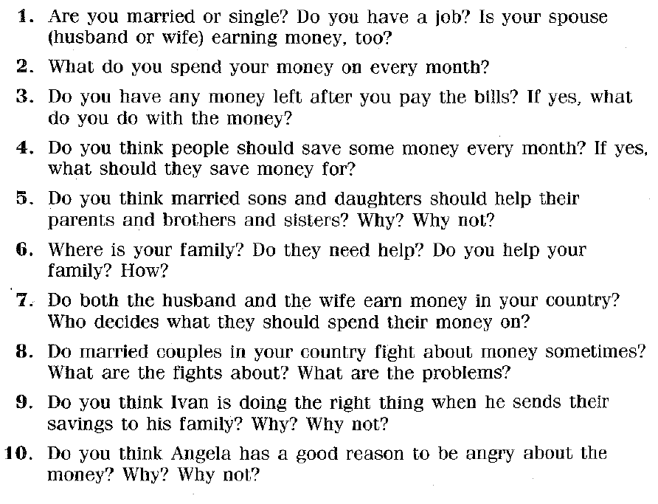

Correct these sentences.
1. This is Angelas famaly.
2. Ivan is welder and Angela is housekeeping.

3. This month Ivan he sent to his brother about $500 dollar.

4. She want to him talk about before he send money.

5. They are no money in there saving account.

6. She getting mad because in their savings account now empty.

7.Maybe future he can’t sent maney without telling she.

