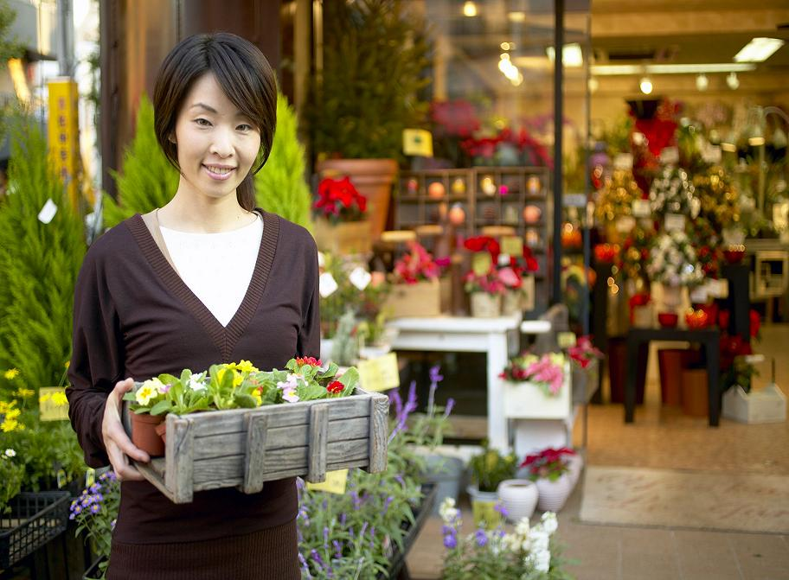

Ann is a florist. She owns her own business and works in St. Paul. Ann isn’t wealthy, but she earns a lot of money on Valentine’s Day because many people buy flowers for their loved ones on that day. Ann began working as a florist 10 years ago, and she enjoys her work very much. She feels lucky in the winter because her job allows her to be around lots of colorful flowers and plants all day.

Fill in the missing verbs in this paragraph.
be own work be (negative) earn buy begin enjoy
feel allow
Ann _______ a florist. She _________ her own business and _________ in St. Paul. Ann _________ rich, but she ___________ a lot of money on Valentine’s Day because many people _________ flowers for their loved ones on that day. Ann _____________ working as a florist 10 years ago, and she ____________ her work very much. She ____________lucky in the winter because her job ____________ her to be around lots of colorful flowers and plants all day.

Fill in the missing verbs in this paragraph.
be own work be (negative) earn buy begin enjoy
feel allow
Ann _______ a florist. She _________ her own business and _________ in St. Paul. Ann _________ rich, but she ___________ a lot of money on Valentine’s Day because many people _________ flowers for their loved ones on that day. Ann _____________ working as a florist 10 years ago, and she ____________ her work very much. She ____________lucky in the winter because her job ____________ her to be around lots of colorful flowers and plants all day.
Fill in the missing verbs in this paragraph.
be own work be (negative) earn buy begin enjoy
feel allow
Ann _______ a florist. She _________ her own business and _________ in St. Paul. Ann _________ rich, but she ___________ a lot of money on Valentine’s Day because many people _________ flowers for their loved ones on that day. Ann _____________ working as a florist 10 years ago, and she ____________ her work very much. She ____________lucky in the winter because her job ____________ her to be around lots of colorful flowers and plants all day.

Ann is a florist. She owns her own business and works in St. Paul. Ann isn’t wealthy, but she earns a lot of money on Valentine’s Day because many people buy flowers for their loved ones on that day. Ann began working as a florist 10 years ago, and she enjoys her work very much. She feels lucky in the winter because her job allows her to be around lots of colorful plants all day.

- On what holiday does Ann earn a lot of money?
_____________________________________________________________________
- Do you think Ann works part-time or fulltime?
_____________________________________________________________________
- How many years of experience does Ann have as a florist?
_____________________________________________________________________
- Does Ann work in Chicago?
_____________________________________________________________________
- Do you think Ann has to be good at talking with customers?
_____________________________________________________________________
- What kind of person is Ann: uncooperative, irresponsible, or independent?
____________________________________________________________________
7. Where do you think florists in Minnesota get their flowers from in the fall and winter?
___________________________________________________________________________
8. In the U.S., it’s a tradition to get flowers for someone you love, when someone gets married, and when someone dies. Do you have any traditions with flowers in your country?
__________________________________________________________________________________________________________________________________________________________

