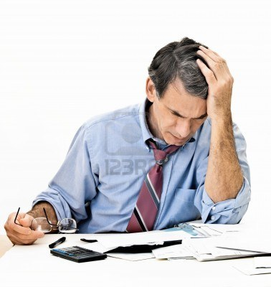

Use these verbs to write sentences about this picture below.
worry about think about try to pay look at
get a headache feel stressed speak sleep well
- At this moment, this man ____________________________________ his bills.
- Every time he looks at his expenses, he ________________________________
- Tonight, I don’t think he ___________________________________________
- He often ______________________________________ when he pays his bills.
- Last night, he ____________________ to a financial advisor.
- He doesn’t like to __________________ his checkbook.
- At present, he ___________________________ how he is going to pay all of his bills.

Bob ___________ very stressed. He ________ a lot of expenses, but he doesn’t have ____________ money to pay his bills. Unfortunately, he ____________ too much money on ____________ last month. He didn’t ____________ cash. Instead, he charged a lot of _________________ to his credit card. He ________________careful with his money, and now he is in _____________.

Dictation:
Bob feels very stressed. He has a lot of expenses, but he doesn’t have enough money to pay his bills. Unfortunately, he spent too much money on gifts last month. He didn’t use cash. Instead, he charged a lot of purchases to his credit card. He wasn’t careful with his money, and now he is in debt.

