Put these verbs in the story. Change them to the simple present tense.
be work take care drive drop off go work pick up help start eat have

Busy Family
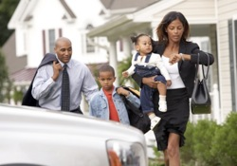
Carla and Mark _________ very busy. They both ___________ full time, and they _______________ of their two young children, Tim and Lucy. Every morning, Carla and Mark ___________ Tim to school, and then they _______________ Lucy at daycare. After that, Mark and Carla _____________ to Wells Fargo Bank where they both _____________ from 8:00A.M to 4:30 P.M. Carla ________ a loan officer, and Michael _________ an office manager. They _________________ their children from daycare at 5:00 P.M. They get home and Mark usually ____________ Tim with his homework, while Carla ______________ making dinner. Then they all ___________dinner together at about 6:00. Like many Americans, Carla, Mark, and their children ____________ very busy weekdays.

1. Where does Carla work? What’s her job?
_____________________________________________________________________
2. Do you think Carla and Mark have one car or two cars? Why do you think that?
_____________________________________________________________________________
3. How many hours will Michael spend at work next week?
_____________________________________________________________________________
4. Is Lucy older or younger than Tim? How do you know?
_____________________________________________________________________________
5. Last Tuesday, what did Mark and Carla do before they drove to work?
_____________________________________________________________________________
6. In this photo, what is Carla doing?
_____________________________________________________________________________

