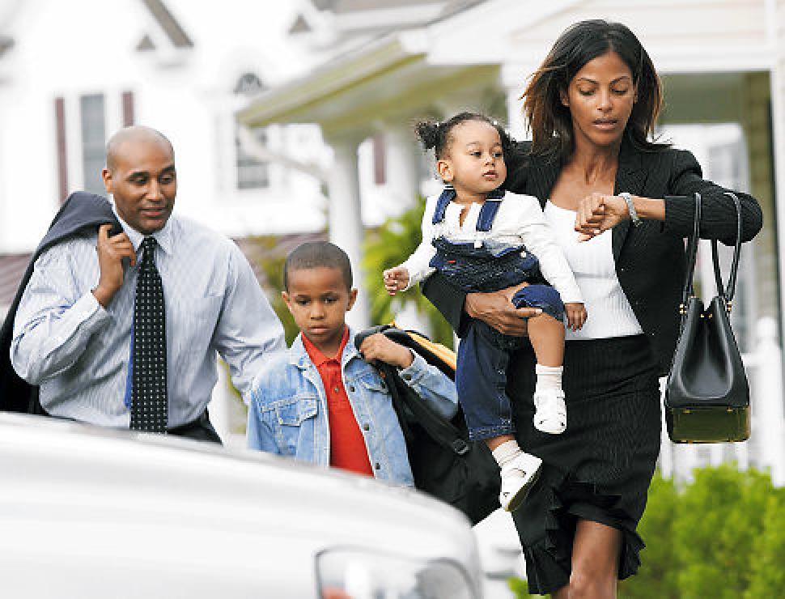

Write about this picture. What are they doing? How are they feeling? What were they doing before? Where are they going? What do they do every morning? What will happen next? Write as much as you can.

