CASAS 186/86 & 187/88
Reading Practice
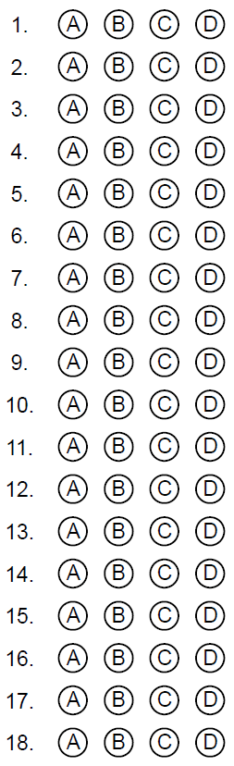
CASAS 186/86 & 187/88
Reading Practice
CASAS 186/86 & 187/88
Reading Practice
CASAS 186/86 & 187/88
Reading Practice

