CASAS Map Reading Practice Answer Sheet
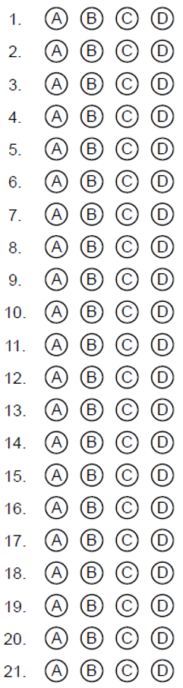
CASAS Map Reading Practice Answer Sheet
CASAS Map Reading Practice Answers
- B
- C
- B
- D
- D
- D
- A
- E
- J
- B
- O
- A
- D (last answer)
- C (3rd answer)
- B
- B
- Mid State Hospital
- C
- B
- D
- D

CASAS Map Reading Practice Answers
- B
- C
- B
- D
- D
- D
- A
- E
- J
- B
- O
- A
- D (last answer)
- C (3rd answer)
- B
- B
- Mid State Hospital
- C
- B
- D
- D

