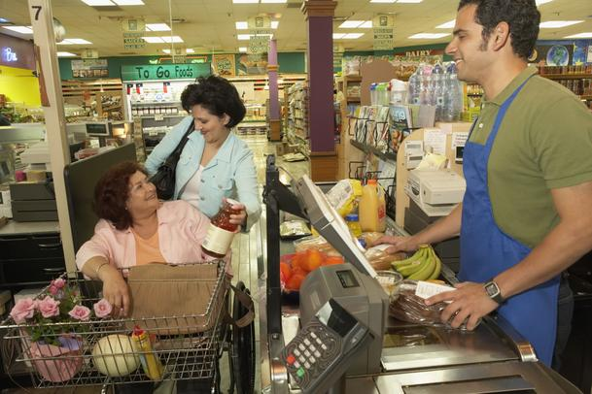

Nouns: cashier, customers, apron, check out, cash register, grocery store, shopping cart, groceries, debit card, bag

Verbs: scan, smile, shop, check out, pay for, talk, ask, put, bag, go, help

What do you see in this picture? What’s happening? Where are they? What were the women doing before? What do they do every week? What will they do next? Write as much as you can.

