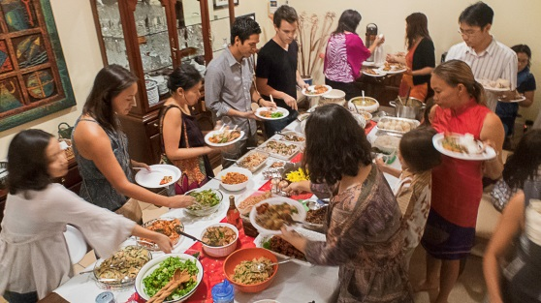

Correct these sentences.
1. I think these peoples are celebrate thanksgiving.

2. Another gril she looks the food.

3. They eat math potatoes, and green beans, and some noodles, and fried rice and beef.

4. They are looks like Sharing Food.

5. Those all foods is so delicious.

6. These a celebration every year celebrate in American culture.

7. there are many food different kind of food in the table.

