Credit and FICO Information (https://www.myfico.com/credit-education/credit-scores/)
Video: What is a FICO Score?
- A FICO score predicts the likelihood that you’ll pay your bills ____ __________.
- The three main credit bureaus are E_________________, E___________________, and T_____________________.
- FICO scores generally range from ____________ to ____________.
Video: How Lenders us FICO Scores
- FICO scores help __________________ understand if you are likely to pay as agreed and if they should extend you ______________.
- Lenders often use FICO scores to set ______________ terms, such as the amount of credit they’ll give you or at what ___________________ rate.
- The bottom line is this: _________________ FICO scores can make a substantial difference in what people, like you, pay for a ______________.
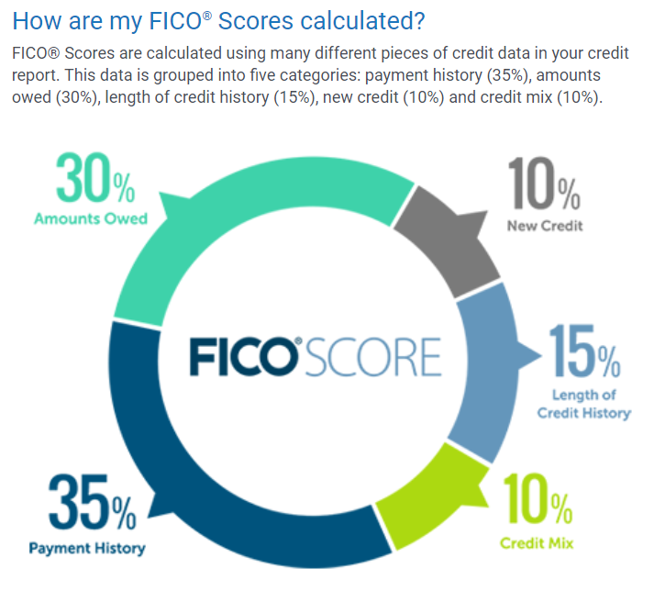
Get a free annual (once a year) credit report (NOT a FICO score) here: https://www.annualcreditreport.com or call 877 322 8228 (press 1 or 2)

