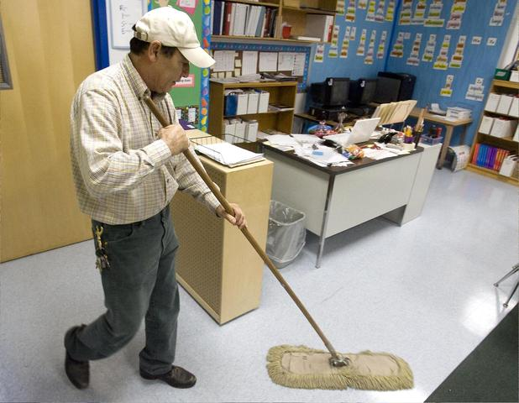
Correct these sentences.
1. He’s mopping floor. ________________________________
2. He work 8:00 hours every week.
____________________________________________________
3. After work he will go to home.
____________________________________________________
4. Piter he is a mexican
_____________________________________________________________________________
5. Piter he go to his job at 9:am when he arrive at work the first think he dose is sweep the floor.
__________________________________________________________________________________________________________________________________________________________
6. He like his job bt his salary is not enough for him and his childrens.
__________________________________________________________________________________________________________________________________________________________
7. He cleans bathrooms mopping pick up garbage dusting and vacuum.
__________________________________________________________________________________________________________________________________________________________
8. He’s paid is $14 p/h. _________________________________________________________
9. He is hard worker good father. __________________________________________________
10. The floor he is cleaning mopping and sweep.
_____________________________________________________________________________

