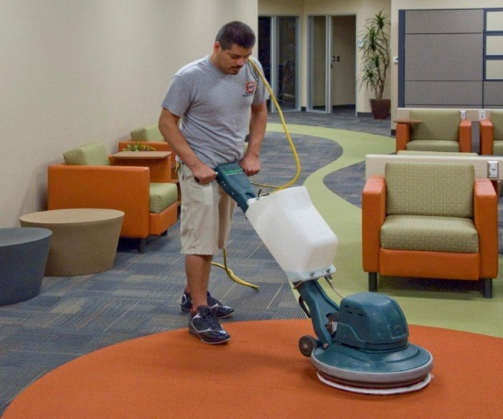
isn’t custodian assisted cleaning will finish
1. Mark is a school _____________________________.
2. He _____________ lazy.
3. A few minutes ago, he ________________________
one of the teachers and helped her move some boxes.
4. In a little while, Mark ___________________ the rest of his duties.
5. Right now he’s _______________________ the carpet.
1. What are a couple of Mark’s job duties?
____________________________________________________________________________
2. Are you a lazy or a responsible worker?
____________________________________________________________________________
3. Did you work yesterday?
____________________________________________________________________________
4. What will you do later today?
____________________________________________________________________________
5. What do you usually do on the weekend?
____________________________________________________________________________
Combine these sentences.
6. Mark is a custodian. He works at a school.
________________________________________________________________________
7. He sweeps the floor. He mops the floor. He cleans the bathrooms.
________________________________________________________________________
8. Mark works Monday through Friday. He works full time.
________________________________________________________________________

