Writing 1 December Assessment – Part I Name: ______________________
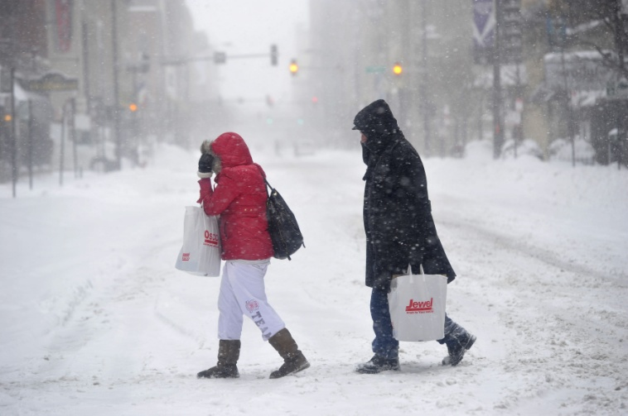

Directions: Look at the picture above, then answer the seven questions below. Make sure that each of your answers is a complete sentence.

- Where are these two people?

________________________________________________________________

- What did these people do a short time ago?

________________________________________________________________

- Do you think these people feel relaxed or uncomfortable?

________________________________________________________________

- Do these adults have children with them?

________________________________________________________________

- Are these people driving?

________________________________________________________________

- Is it snowing or raining in this picture?

________________________________________________________________

- What will happen later?

________________________________________________________________

Writing 1 December Assessment – Part II
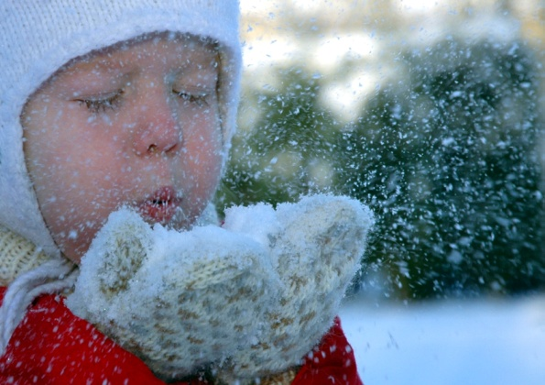
Directions: Use the following predicates to complete the sentences below.

blow snow wear mittens have fun outside play outside
love to go outside snow a lot go inside put on winter clothes
take a nap be cold go sledding have lunch at home

- Hannah always ____________________________________________ in the winter.

- Every winter it _____________________________________________in Minnesota.

- Hannah isn’t _________________________________________________________

- It _________________________________________________________ last night.

- In about 15 minutes, Hannah ____________________________________________

- At this time, Hannah ___________________________________________________

- It __________________________________________________________ right now.

- Yesterday Hannah ________________________________________with her friends.

