Writing 1 December Practice Assessment – Part I
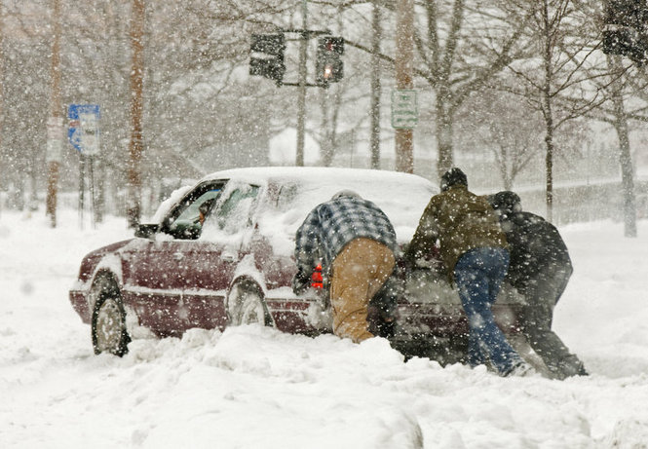

Directions: Look at the picture above and then answer the questions below. Make sure that each of your answers is a complete sentence.

- What are these three people doing to this car?

________________________________________________________________

- What is this driver’s problem?

________________________________________________________________

- Do you think this is a dangerous or fun situation?

________________________________________________________________

- Why did the driver roll down his window?

________________________________________________________________

- Is it snowing lightly or heavily?

________________________________________________________________

- Why do you think this person is driving in a snowstorm?

________________________________________________________________

- What will happen later?

________________________________________________________________

Writing 1 December Practice Assessment – Part 2
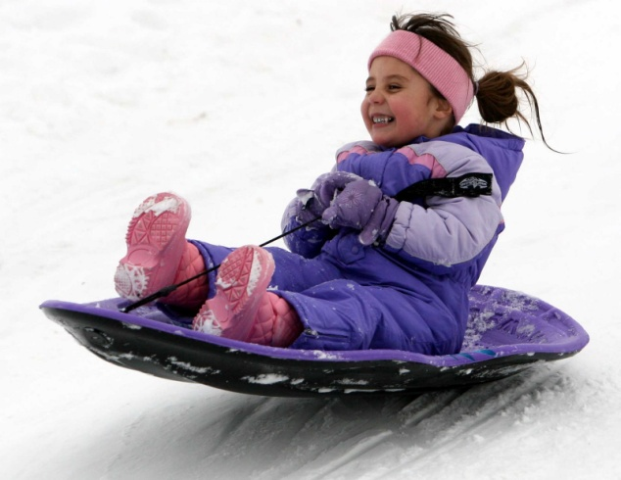
Use these verbs to complete the sentences. Change the verb tense, if you need to
smile and laugh wear warm clothes enjoy a winter day
feel excited wear a hat go inside to get warm move to Minnesota have fun at a park play inside
be a cold, sunny day snow a lot go sledding

- Mia _______________________________________ every time she goes sledding.

- Last year her family __________________________________________________

- At this time, Mia _____________________________________________________

- She isn’t ____________________________________________________________

- Earlier today Mia _____________________________________________________

- Later today Mia ______________________________________________________

- Right now Mia ________________________________________________________

- It _____________________________________________________ today.

- Yesterday it ____________________________________________ where Mia lives.

- Mia ______________________________________________ after every snowstorm.

