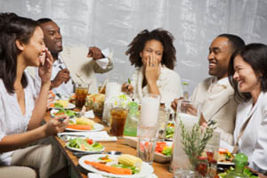

These people are enjoying a holiday party. Every December they get together for dinner at one of their homes. Each of the guests usually brings something to share at the dinner party like salad, bread, drinks or dessert. At this time, these friends are telling each other funny stories. When they laugh together, they feel relaxed. They’re having a lot of fun at this dinner. When dinner is over, they will all help to clean up, talk awhile longer, and then they’ll go home. Tomorrow is Sunday, and they will think about the party and text their friend who had the party at his house to thank him.

- Who are these people?
___________________________________________________________________
- Why are they smiling?
___________________________________________________________________
- What are they doing?
__________________________________________________________________
- Will they go to work tomorrow?
__________________________________________________________________
- How many women are at this party?
___________________________________________________________________
- Are they at a restaurant?
___________________________________________________________________
- What did these friends do last December?
___________________________________________________________________
- How do guests usually help with these group dinners? ____________________________________________________________________
- What will the guests do on Sunday?
_________________________________________________________________________

Directions: Correct the 17 mistakes that are in the following paragraph.
These people are enjoy a holiday party. Every december they got together for dinner at one their homes. Usually, each of the guests bring something to share at the dinner party like salad bread drinks or dessert. At this time, these friend are telling each other funny storys. When they laugh together, they feel relaxing. There having a lot of fan at this dinner. When dinner is over, they will all helping to clean up, talk awhile longer and then they’ll go home. tomorrow is Sunday and they will thought about the party and text their friend who had the party his house to thanks him.

Directions: Correct the 17 mistakes that are in the following paragraph.
These people are enjoy a holiday party. Every december they got together for dinner at one their homes. Usually, each of the guests bring something to share at the dinner party like salad bread drinks or dessert. At this time, these friend are telling each other funny storys. When they laugh together, they feel relaxing. There having a lot of fan at this dinner. When dinner is over, they will all helping to clean up, talk awhile longer and then they’ll go home. tomorrow is Sunday and they will thought about the party and text their friend who had the party his house to thanks him.

