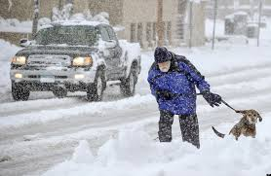
Ed is not afraid of snowstorms and cold winter weather. He is a life-long resident of St. Paul, and he is used to winter weather. When it snows heavily, Ed doesn’t drive; he prefers to walk. Even when the weather is very bad, Ed and his dog, Benny, always take two walks a day. Benny doesn’t like winter weather as much as Ed, but he is a loyal dog, and he follows Ed wherever he goes.

1. Do snowstorms make Ed nervous?

2. How many walks does Ed take with Benny each week?

3. Do you think Ed is a lazy person or an active person?

4. Who dislikes winter weather more, Ed or Benny?

5. Why do you think Ed doesn’t drive when it snows heavily?

6. How do you feel about bad winter weather?

