English for All: Episode 13 Parenting in the U.S. True (T) or False (F)
1. ___Viviana wants to go to a friend’s party.
2. ___Marta gives Viviana permission to go to the party.
3. ___Benjamin, Viviana’s father is happy to let her go to the party.
4. ___Viviana and her mother don’t spend time together. 5. ___Marta likes Cornelio.
6. ___Cornelio wants to give Marta a ride to work. 7. ___Marta is having problems with Viviana.
8. ___Dora tells Marta to send Viviana back to Mexico. 9. ___Dora thinks Viviana is a good student.

1. What’s this?
- A list b. A letter c. A ticket

2. These points are for a…
- job application b. school class c. police officer

3. How many questions do you answer in a job application?
- 20 b. all c. none

4. When you fill out a job application, you need to…
- be fast b. use pencil c. print clearly

5. Your address needs to be…
- in the city b. the most current c. local

6. You need a current __________ for the employer to contact you.
- phone number b. ID c. good friend

7. As long as you get the job, is it OK to lie?
- Sometimes b. Yes c. No!

8. When you go for a job, your attitude should be…
- positive b. negative c. playful

9. The most important item in a job application is…
- the last name b. the signature c. everything

10. How many points are there on the above information sheet?
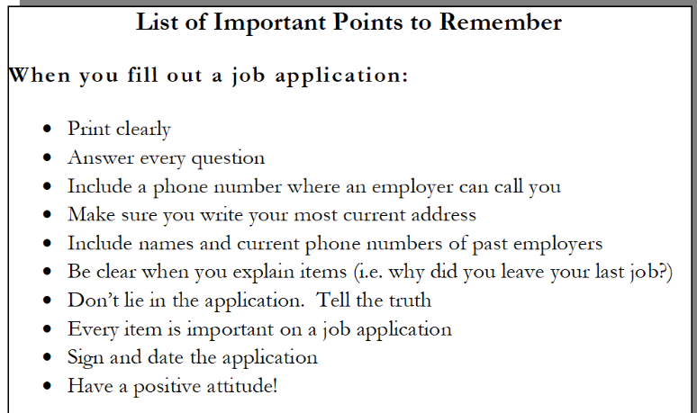
- 1 b. 10 c. 20

