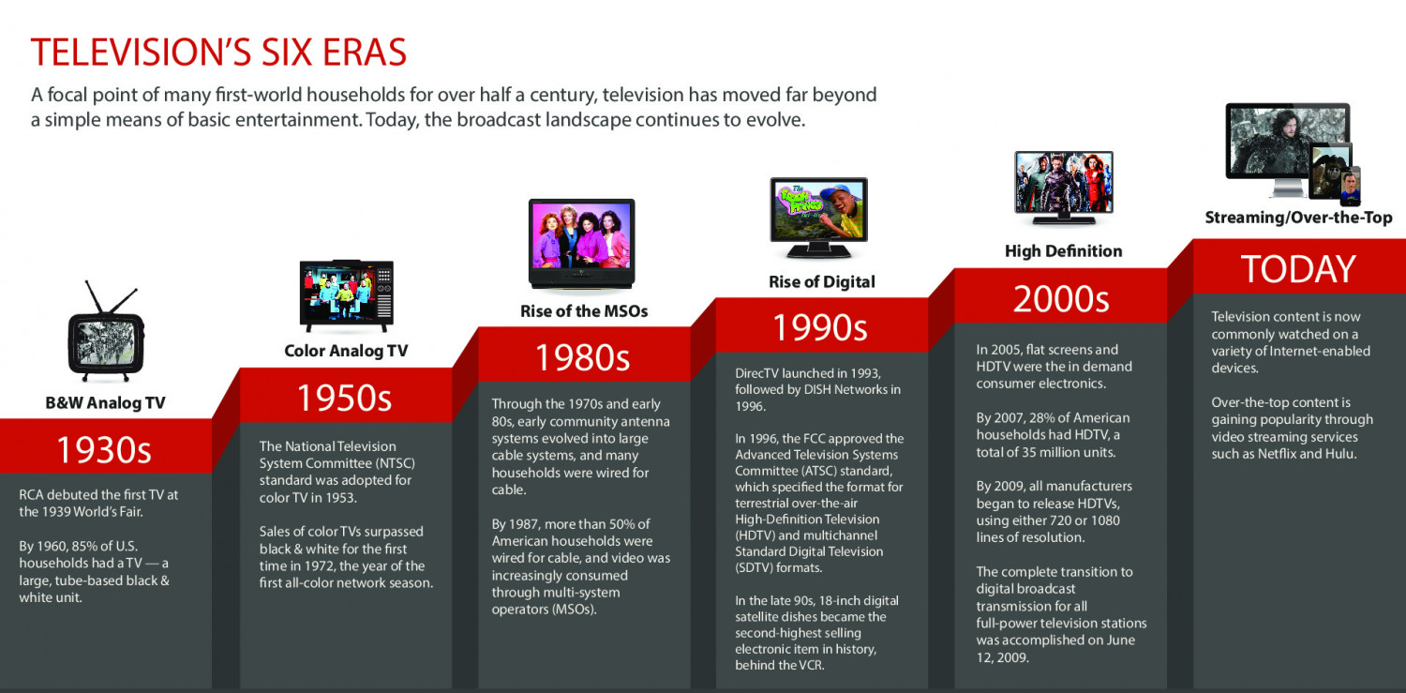
Evolution of Television (TV) 1920-2020 (https://youtu.be/PveVwQhNnq8)
Write a short summary of what your learned and saw in this video and infographic. Try to write 4-6 sentences.
________________________________________________________________________________________________________________________________________________________________________________________________________________________________________________________________________________________________________________________________________________________________________________________________________________________________________________________________________________________________________
__________________________________________________________________________________________________________________________

