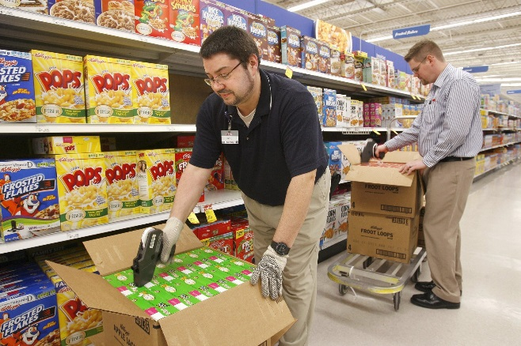
Fact, Inference, Opinion Quiz
1. Match the examples:
Fact These two men work at Cub Foods.
Inference One man is wearing work gloves.
Opinion Their job is pretty easy.

2. Look at this picture. Write one fact, inference, and opinion about this picture.
F: ________________________________________________________________________________
I: _________________________________________________________________________________
O: ________________________________________________________________________________

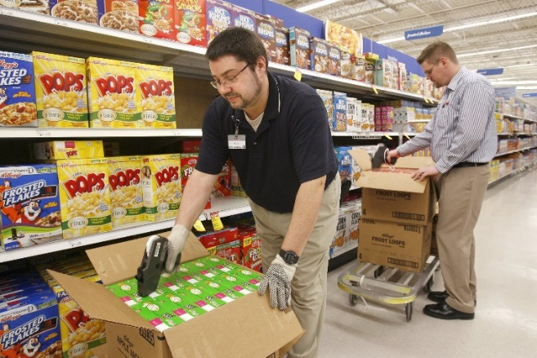
Fact, Inference, Opinion Quiz
1. Match the examples:
Fact These two men work at Cub Foods.
Inference One man is wearing work gloves.
Opinion Their job is pretty easy.

2. Look at this picture. Write one fact, inference, and opinion about this picture.
F: ________________________________________________________________________________
I: _________________________________________________________________________________
O: ________________________________________________________________________________

