1. Match the examples:
Fact Being an adult student and learning English is easy.
Inference The Hubbs Center has only adult students.
Opinion Most of the adult students also work.
2. What is a fact? ______________________________________________________________
What is an inference? ___________________________________________________________
What is an opinion? ____________________________________________________________
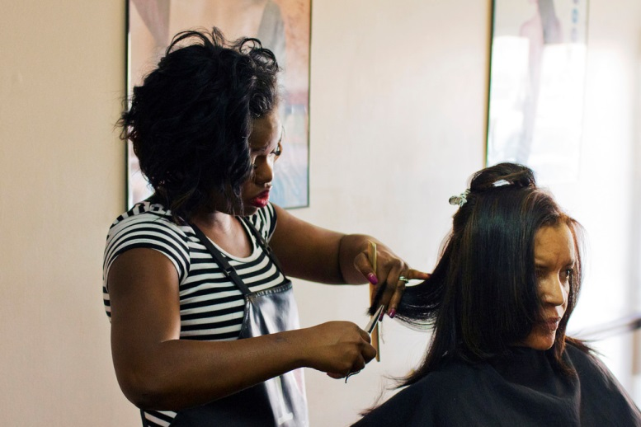
3. Look at this picture. Write one fact, inference, and opinion about this picture.
F: ____________________________________
____________________________________
I: ____________________________________
____________________________________
O: ____________________________________
____________________________________

1. Match the examples:
Fact Being an adult student and learning English is easy.
Inference The Hubbs Center has only adult students.
Opinion Most of the adult students also work.
2. What is a fact? ______________________________________________________________
What is an inference? ___________________________________________________________
What is an opinion? ____________________________________________________________
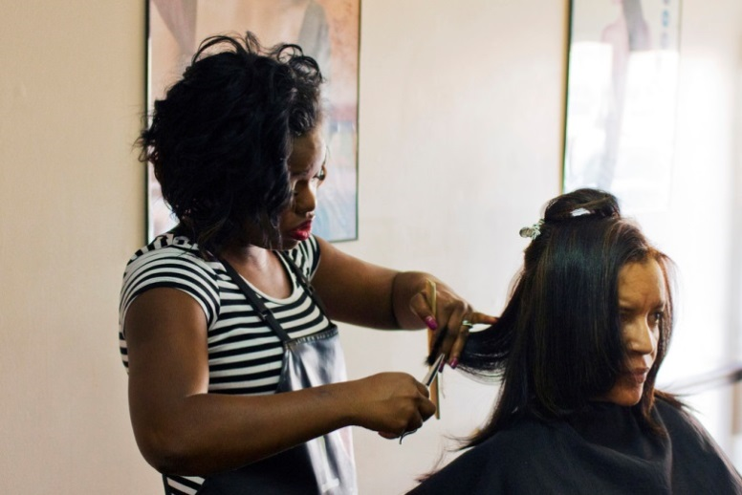
3. Look at this picture. Write one fact, inference, and opinion about this picture.
F: ____________________________________
____________________________________
I: ____________________________________
____________________________________
O:____________________________________
____________________________________

