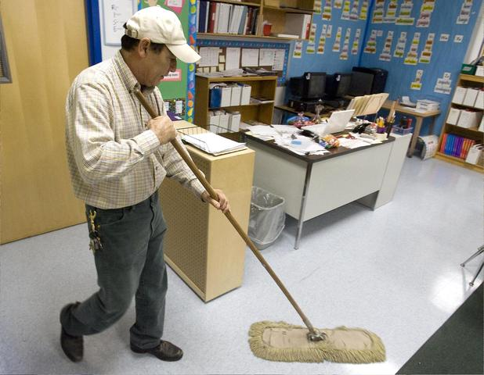
Fact vs. Inference Quiz
Write F or I in the blanks.
1. He is mopping the floor. ______
2. He is tired. _____
3. He’s mopping in a classroom. ______
4. He’s wearing keys on his belt. ______
5. He must wear a hat while he’s working. _____
6. He will take out the garbage next. _____
7. He likes his job. _____
8. He works full time, Mon-Fri. ______
9. He is looking at the mop. _____
10. The floor is very dirty. _____
11. His jeans are clean. _____
12. His shirt is tucked into his jeans. _____
13. There are students in this classroom. _____
14. He usually mops the floor after school. _____
15. He doesn’t have a beard. _____
Write two facts and two inferences.
1. _________________________________________________________________________________
2. _________________________________________________________________________________
1. _________________________________________________________________________________
2. _________________________________________________________________________________

Fact vs. Inference Quiz
Write F or I in the blanks.
1. He is mopping the floor. ______
2. He is tired. _____
3. He’s mopping in a classroom. ______
4. He’s wearing keys on his belt. ______
5. He must wear a hat while he’s working. _____
6. He will take out the garbage next. _____
7. He likes his job. _____
8. He works full time, Mon-Fri. ______
9. He is looking at the mop. _____
10. The floor is very dirty. _____
11. His jeans are clean. _____
12. His shirt is tucked into his jeans. _____
13. There are students in this classroom. _____
14. He usually mops the floor after school. _____
15. He doesn’t have a beard. _____
Write two facts and two inferences.
1. _________________________________________________________________________________
2. _________________________________________________________________________________
1. _________________________________________________________________________________
2. _________________________________________________________________________________

