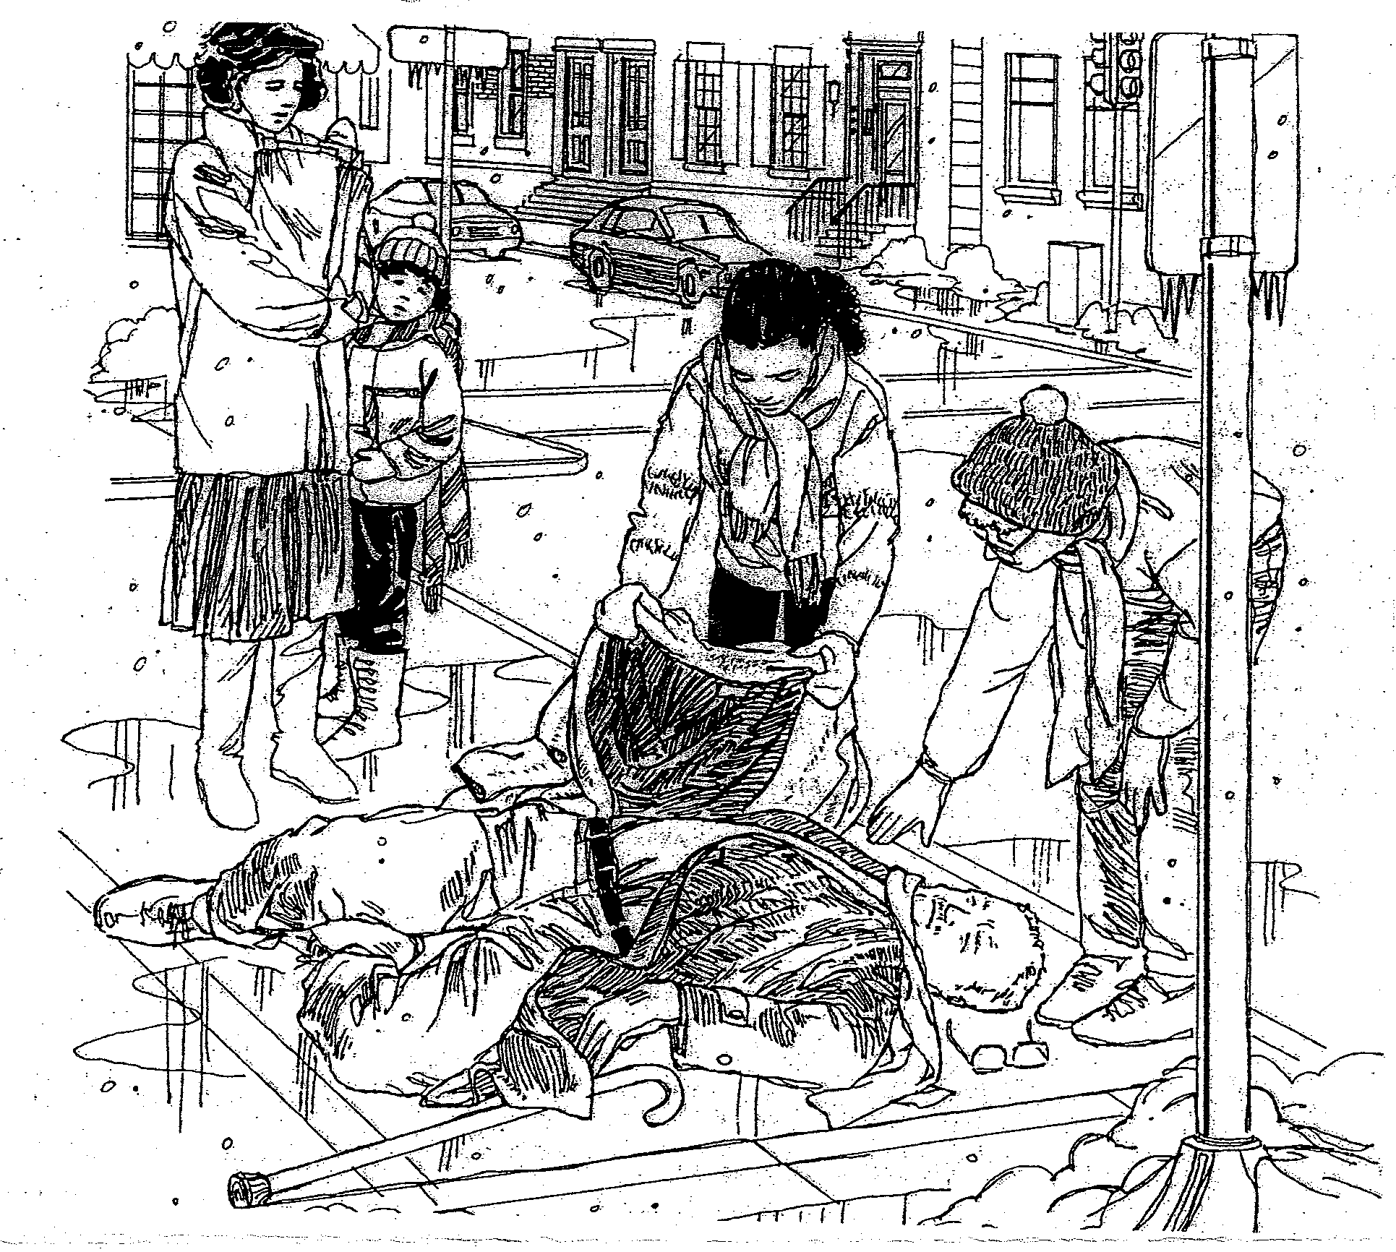
What happened? What is happening? What will happen next? Write for 15-20 minutes.

