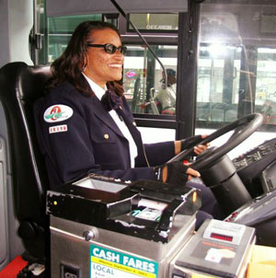

Write as much as you can about this picture. Try to use all four basic verb tenses: past, present, present continuous (-ing), and future.

