Basic Rules for Gerunds and Infinitives
Gerunds and infinitives can replace a noun in a sentence.
Gerund = the present participle (-ing) form of the verb: singing, dancing, running
Infinitive = to + the base form of the verb: to sing, to dance, to run
Whether you use a gerund or an infinitive depends on the main verb in the sentence.
I plan to have the results of the test soon. (Infinitive)
I plan on having the tests corrected soon. (Gerund)
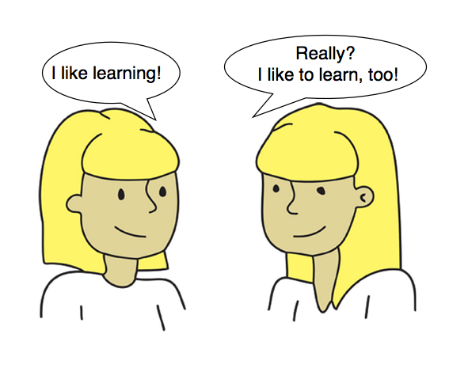
Gerunds can be used after certain verbs such as: enjoy, like, discuss, dislike, finish, mind, suggest, recommend, keep, and avoid.
1) After prepositions of place and time.
I made dinner before getting home.
He looked unhappy after seeing his work schedule.
2) To replace the subject or object of a sentence
Lachlan likes eating coconut oil.
Jumping off a cliff is dangerous, but a real thrill.
Infinitives can be used after certain verbs such as: agree, ask, decide, help, plan, hope, learn, want, would like, and promise.
1) After many adjectives:
It is hard to make dinner this late.
I find it difficult to describe my feelings about girlfriend.
2) To show purpose (reason):
I went on the trip to study Russian.
I came to the office to do some work.
There are also many verbs that can take both a gerund and an infinitive.
You just need to practice using them to get more comfortable with them.
Most students enjoy practicing and using gerunds and infinitives.

