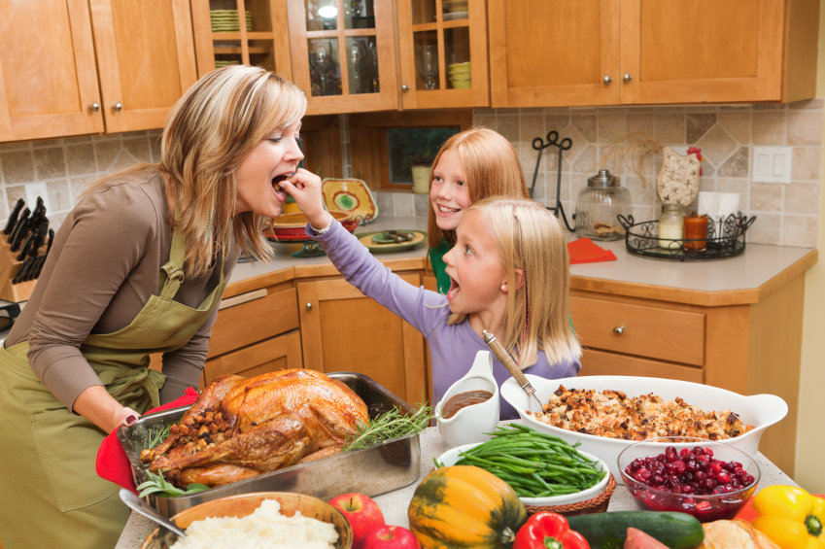
What is happening in this photo?

What happened earlier?

What always happens at this time of year?

What will happen later?

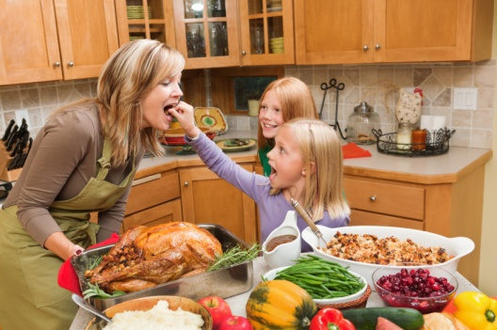

What is happening in this picture? (present continuous)
- Ana and her two daughters are celebrating a holiday.
- The mother is cooking a big dinner.
- This mother and her two daughters are cooking.
- A mother and her two beautiful daughters are having fun in the kitchen together.
- These people are preparing a big dinner.

What happened before? (past)

- Earlier today Maria went to the grocery store to buy everything she needed to make dinner.
- Last week Regina invited all of her family members and her husband’s family members to celebrate Thanksgiving together at her house.
- Nina put a lot of different food on the table a few moments ago.

What always happens at this time of year? (simple present)

- Every year this woman and her daughters celebrate New Year’s Day with a big dinner.
- Every year this woman always cooks a big turkey for Thanksgiving.
- One of these girls always likes to put things in her mother’s mouth.
- This family always eats a big dinner on Thanksgiving.
What will happen later? (simple future)
- Later Regina and her family will have dinner. Then they will dance, talk together, and play Bingo.
- This family will eat dinner together soon.
- After dinner, they will listen to music to relax.
- After dinner, they will feel very happy and very full.

