Lan is a Chef
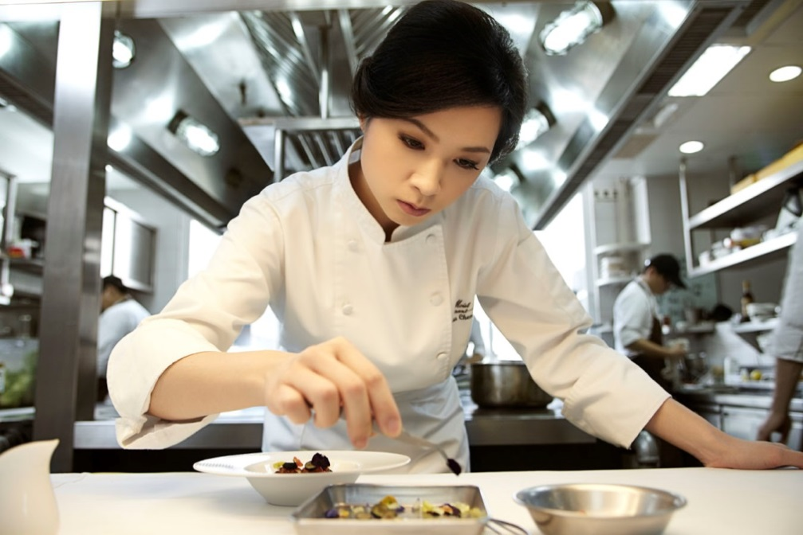
Vocabulary
Nouns: restaurant, kitchen, counter, dishes, bowls, utensil, plates, food, customers, order, cooks, prep cook, server, manager, owner, uniform, hat,

Verbs: work, prepare, make, tell, order, use, wash, clean, organize, serve, take order,

Adjectives: clean, bright, busy, prepared, quickly, excellent, expensive,

Write as much as you can about this picture. Try to use past, present, present continuous, and future tense. Try to write a couple sentences with gerunds and infinitives.

