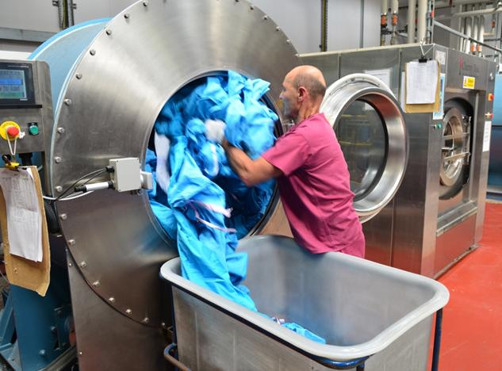
Correct these sentences about the laundry worker.
1. He is job is a laundry worker.
________________________________________________
2. He is get paid $15 dollars 1 hour.
________________________________________________
3. He watching closths in the watching machine.
_________________________________________________
4. His job duties are to sort load unload fold the laundry.
_____________________________________________________________________________
5. I think he not get very much pay.
_____________________________________________________________________________
6. He works on haspital. ________________________________________________________
7. He part time work 30 hour a week. ______________________________________________
8. He put on gloves gown before he start to work.
_____________________________________________________________________________
Correct these sentences about the laundry worker.
1. He is job is a laundry worker.
______________________________________________
2. He is get paid $15 dollars 1 hour.
______________________________________________
3. He watching closths in the watching machine.
_______________________________________________
4. His job duties are to sort load unload fold the laundry.
_____________________________________________________________________________
5. I think he not get very much pay.
_____________________________________________________________________________
6. He works on haspital. ________________________________________________________
7. He part time work 30 hour a week. ______________________________________________
8. He put on gloves gown before he start to work.
_____________________________________________________________________________

