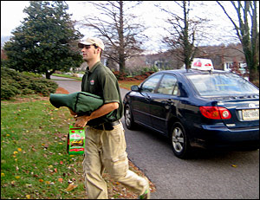
Mark the Pizza Delivery Driver (in, at, on, for, from)
This is Mark. He is a pizza delivery driver.
He works ______ Papa Johns Pizza ____ night
and ____ the weekend. He usually works _____
4:00 to 11:00pm. He delivers pizza _____ his
car. He’s always _____ time to work. He
answers the phone and takes orders. He types the
orders _____ the computer. He takes the pizzas
out of the oven. They’re very hot. He cuts the pizza and puts it ______ a box. Then he puts the pizza _____ a hot bag, brings it out to his car and puts it _____ the seat. He reads the address and drives there. When he arrives _____ the house, he gets out of his car and walks up to the door. He knocks _____ the door. The customer pays him and usually gives him a tip. Mark likes big tips. He says, “Thank you! Have a nice night.” Then he gets back ____ his car and drives to the store ____ another delivery. When they’re really busy, he has to answers the phone, take orders _______ the customers, and enter the order _____ the computer. Being a pizza delivery driver can be fun, but it can also be stressful. ____ really busy nights, it’s stressful, and customers sometimes get angry and yell _____ Mark if they’re pizza is late. He always tries to be friendly with the customers, even when they are rude or don’t tip. He works hard _____ his family. He hopes someday he can find a more professional job. He is also thinking about jobs where he can work _______ home.

