“Merry Christmas”
Christmas is a festive time. You can see it. You can smell it. You can hear it. The sights, smells, and sounds of Christmas are celebrated by millions of people every year all over the world. It is a religious holiday for Christians celebrating the birth of Jesus Christ more than 2000 years ago, but many non-Christians also celebrate and enjoy the holiday.
What do you see at Christmas? People put up lights on their homes and decorate Christmas trees. Wreaths are hung on doors. People wear red and green clothing. Some people even have Santa Claus and his reindeer and snowmen on their lawn! Many people put up Christmas trees in their homes, and decorate them with lights and ornaments. They will put presents underneath the tree. You will see many people out shopping for gifts. You may receive some Christmas cards in your mailbox. Many people send holiday greeting cards or emails to their family members and friends. A family photo and letter of the past year’s events are often included in the card. There are also sights of Christmas in the newspaper, on TV, and online. You see ads for special sales in most stores and online sites. And don’t forget Santa Claus! He can be seen in most shopping malls where children line up to tell him what they want for Christmas.
What do you smell at Christmas? Christmas cookies are baked by young and old. Frosted cut-out cookies are a favorite. You see them in many shapes. There are green trees, yellow stars and red stockings. Many families make them every year. They are a Christmas tradition. You may also smell a feast for Christmas dinner. Many families and friends gather for a large meal, like they do for Thanksgiving.
What do you hear at Christmas? Frosty the Snowman, Rudolph the Red Nosed Reindeer, and Jingle Bells are common Christmas-time songs. Christmas carols are also enjoyed by all. Religious songs like Away in the Manger and Silent Night are also favorite carols of the season. Other sounds you may hear include friendly Christmas greetings. People say, “Merry Christmas” and “Happy Holidays” to friends and strangers. You will also hear the sound of cash registers ringing! Christmas is a busy time for shopping and buying of gifts for family and friends. You may hear bell-ringers who collect money for the Salvation Army, who help many people who are poor or homeless around the holidays.
The sights, smells and sounds of Christmas are many. People of all ages and backgrounds share the spirit of the season. Christmas is a time for being with family and giving to others.
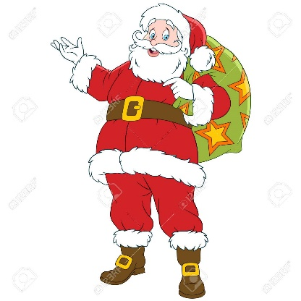
In the United States, Christmas is a national holiday and is celebrated every year on December 25th . Many businesses also close early or are closed on Christmas Eve, December 24th. Many people take vacation time or paid time off to be with family or travel during Christmas-time. Even though it’s a Christian holiday, it’s been a national holiday in the U.S. since 1870.
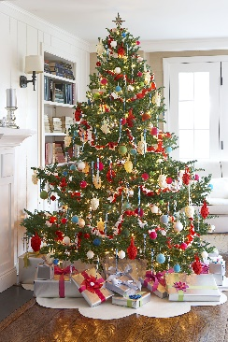

1. Match the vocabulary words from the reading with the definitions:

____ 1. festive a. special songs for Christmas

____ 2. twinkle b. cheerful and exciting

____ 3. tradition c. to observe a certain day or time with special activities

____ 4. celebrate d. to shine with light

____ 5. carols e. something done over and over again in the same way

____ 6. cash register f. computer/machine used to calculate prices and cost for customers

2. “You might see a snowman in front of someone’s house.” In which paragraph would this detail go in the reading?

3. “People love the smell of Christmas trees in their homes.” In which paragraph would this detail go in the reading?

4. List three things you can see during Christmas-time:

5. What is the main idea of this reading?

6. Write two questions that you can answer from the story.
Why ____________________________________________________________________________________________?
Answer: _______________________________________________________________________________________________________________
What ___________________________________________________________________________________________?
Answer: _______________________________________________________________________________________________________________
7. If you’re not a Christian, can you still celebrate Christmas if you want to? Yes No Maybe
8. Do you celebrate Christmas? Yes No
9. Is Santa Claus a real person? Yes No I don’t know.

