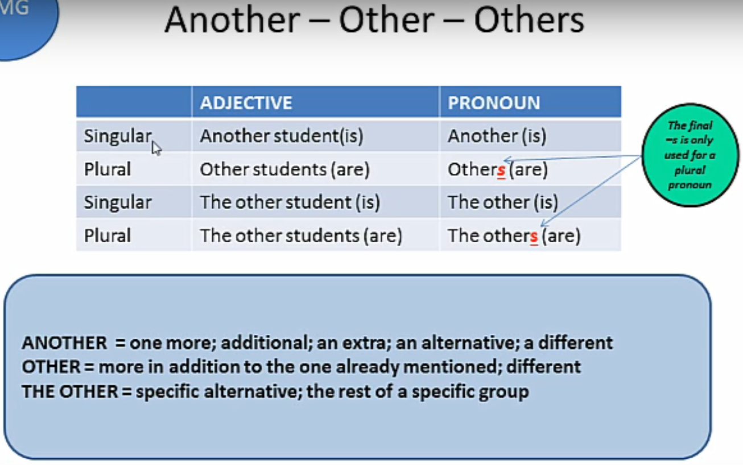
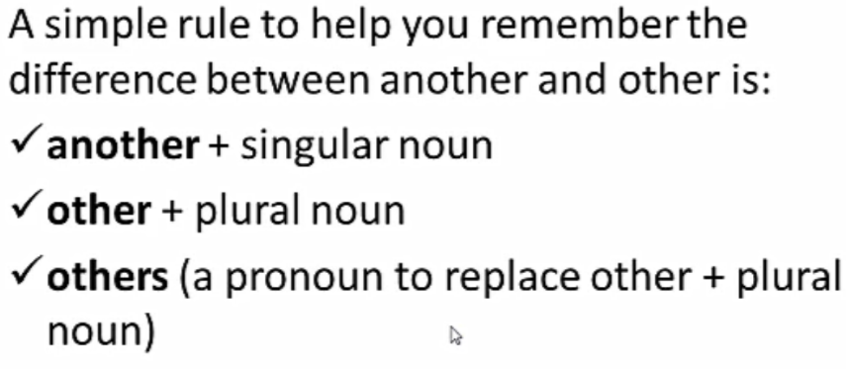
Examples:
Some students learn quickly, but other students need more time.
Do you have any other questions?
I have one shoe, but I can’t find the other one.
The pizza is delicious. Can I have another piece?
I’m sorry I hurt your feelings. Please give me another chance.
I don’t understand. Please explain that another time.
We need another player. Does you friend John want to play basketball with us?
Some students are testing. The others are in the classroom.
There’s not just one answer to the question. There are others.
These shoes are too small. Do you have any others?
Fill in the blanks with other, others, or another.
- There’s no ____________ way to unlock the door. Try again.
- Some people like to rest on vacation. _____________ like to travel.
- This cake is delicious! Can I have ________________ slice, please?
- Where are the ______________ boys?
- The bus stop is on the ______________ side of the street.
- There were four books on my desk. One is here, but where are the ____________?
- He just quit. He found _________________ job.
- Would you like ______________ cup of coffee, ma’am?
- I have been to Canada, the U.S.A, and many ____________ countries.
- I think we should break up. I want to date _____________ people.
- I talked to Samsam and Ahmed, but I haven’t talked to the ______________ yet.
- You can ask me _________________ question, if you want to know more.
- Only 5 computers are working right now. The _____________ are broken.
- Many people voted ‘yes,’ some people voted ‘no,’ and ____________ didn’t vote.
- You’re tired already? We have many _____________ exercises left to do.
Write one sentence with other, others, and another.
- ________________________________________________________________________
- ________________________________________________________________________
- ________________________________________________________________________
Find a partner. Take turns reading this conversation with them.
Person A: Hey, it’s time to leave for the movie. Let’s go.
Person B: I’m looking for my shoes. I have one, but I can’t find the other one.
Person A: Did you look by the other shoes?
Person B: Yes. I found another pair of my shoes, but not the one I need.
Person A: Why don’t you just put on the other pair of shoes?
Person B: Ok, I’ll. I look for my missing shoe another time.
Person A: I’ll text the others to let them know we’re on our way.

