Present Perfect Stories
Linda has just walked outside with her grandmother. She is wearing an apron because she had just finished cleaning and washing in the house. She has also gathered seeds and bread crumbs in her apron to feed their chickens. She is dropping the seeds and crumbs on the ground, but the chickens haven’t come yet.
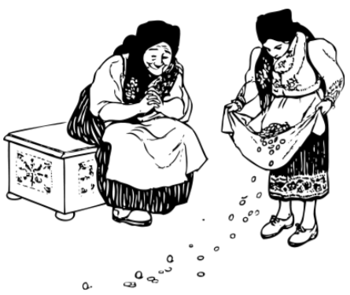
Grandma has recently moved in with Linda’s family. She has lived with them for a month. She enjoys living with them. Grandma is sitting on bench and waiting for the chickens to arrive. She likes to watch them eat. She’s taking a break because she has just finished preparing food for dinner. She has cooked and prepared food for almost two hours.

1. Underline all the present perfect verbs.
2. Re-write the following present perfect sentences.
She has lived with them for a month.
Negative: ___________________________________________
Yes/No question: ___________________________________________
Wh-question: ______________________________________________
Mable Jones live in Florida, but her two grandchildren live in Minnesota. They have lived in Minnesota for 3 years. Mable hasn’t seen her grandchildren in more than a year. She talks to them on the phone and on Facetime. She has seen some pictures of her grandchildren recently because her daughter texted them. They have grown so much since that last time she saw them!
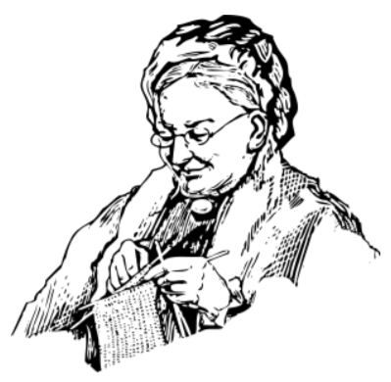
Mable likes to knit scarves and blankets for her grandchildren. So far, she has knitted a blanket and a scarf for each of them. She plans to make them a new scarf ever winter. She hasn’t had time to buy some new yarn to knit with, but she plans to buy some soon.

1. Underline all the present perfect verbs.
2. Re-write the following present perfect sentences.
They have grown so much.
Negative: _________________________________________________
Yes/No question: ___________________________________________
Wh-question: ______________________________________________

