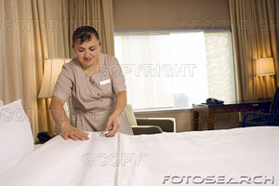
Change this story to the simple present tense.

Rosa’s Job
This is Rosa. She was a housekeeper at a hotel in Minneapolis. She did many things at her job. She vacuumed, made the bed, and dusted. She took out dirty towels and brought in clean towels. She scrubbed the sink, the toilet, and the shower. She changed the soap and shampoo. She collected the dirty towels and put them in a bin. She helped hotel guests when they asked a question. She usually cleaned 20 rooms during her shift. She usually worked from 9:30am to 4:30pm five days, or about 35 hours a week.
Rosa was a housekeeper for 3 years. She often liked her job, but sometimes she didn’t like it. She got tired, and her feet and lower back hurt because she stood all day. When she took a break, she sat down, closed her eyes, and drank some coffee.

