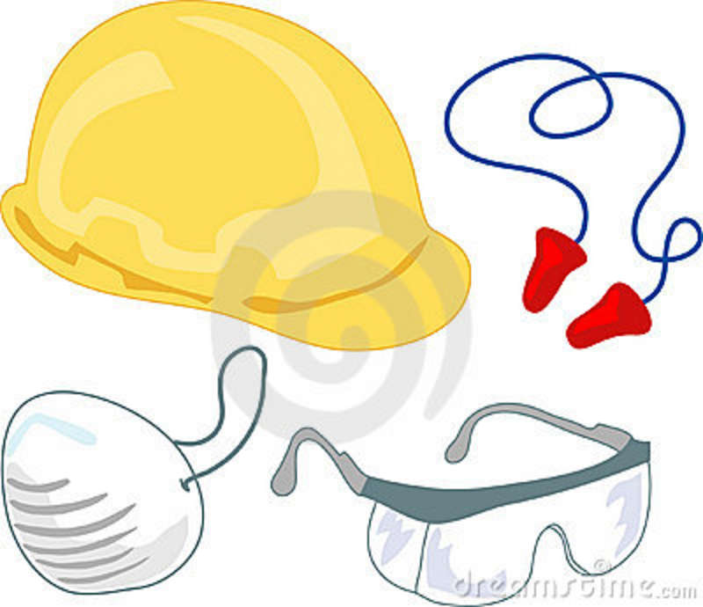
Safety Gear (from Marshall ABE Level 4.5)
Staying _________ and healthy at work is very important. Your employer does not want you to get ________ on the job. It is important to always use the right __________ on the job. Many people need special gear at work.
Maria and Carlos ___________ industrial fabrics. They wash the fabrics with liquid chemicals. Sometimes these chemicals __________. Maria and Carlos must wear rubber __________ so that they don't slip on wet floors. They must also wear ______________ gloves to protect their hands from the chemicals. Rubber boots and gloves are __________________ for workers’ safety.
Mary is a cook at a ___________________. She is required to wear a hairnet at work. She
does not like _______________ her hairnet, but she understands why it’s important. Hairnets keep hair out of the food. Hairnets also keep long hair from _______________ caught in the blenders and mixers cooks use. Mary wears an apron to _______________ her clothing.
Always use the right ______________ gear on the job. The gear will protect you from getting hurt. If your gear is _______________, tell your supervisor right away so he/she can help you get new gear.

1. Why do some employees need to wear safety gear at work?

________________________________________________________________________

2. What does Mary wear to protect her clothing?

________________________________________________________________________

3. Why does Maria wear gloves when she is at work?

________________________________________________________________________

4. According to this passage, who can help a worker replace broken safety equipment?

________________________________________________________________________

5. Does Maria enjoy wearing a hairnet at work?

________________________________________________________________________

