Shopping Online For a New TV
Mai and Thao just moved in to a new apartment in
St. Paul. The have budgeted for a new TV. They have
both been saving $50 a month for three months, so they
have about $300 to spend. The Rosedale Mall and other
stores that sell electronics, like Best Buy, are not too far,
but they know this is a busy time of year for shopping.
The wanted to avoid the crowds, so they decided to shop online with Thao’s iPad.
Mai knows that most stores have free in-store pickup for any purchases done online. If they find a TV they like, they can buy it, then pick it up at the store when it’s convenient. They decided to check out bestbuy.com.
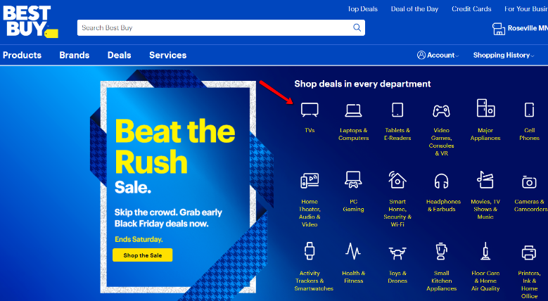
The Best Buy website had a lot of information. Mai and Thao felt overwhelmed by the choices. They weren’t sure where to click first. There was an icon that said TVs, so they clicked on that. There were still so many TVs to choose from! They realized they needed to make a list of things they wanted the TV to be.
Here’s their list:
- Store Pickup at the Roseville Best Buy store
- Price: $300 maximum
- TV Screen Size: 40-43 inches
- Customer rating: 4 stars or more
- Resolution: 1080p - Full HD

On the website, they used the menu on the left side to narrow their choices. After they made these selections, the website showed them 7 TVs that met their search criteria. They were happily surprised to find out that most of TVs were under $200! They had saved more than enough money. They chose an Insignia $43 inch TV that cost $149.99.
They clicked to add it to their cart, chose Free Pickup at the Roseville store, and paid online with Mai’s credit card. Before they could check out, they had to enter some information, including Mai’s name, address, email, phone number, etc. They had to enter her credit card number, expiration date, and the CVC number on the back of her card. A few minutes later, she received an email receipt with her order number and confirmation. About one hour later, she received another email saying their order was ready to pick up in the store! All they had to do was bring in her phone to the pick up desk and show the cashier the email receipt with the bar code, like this:
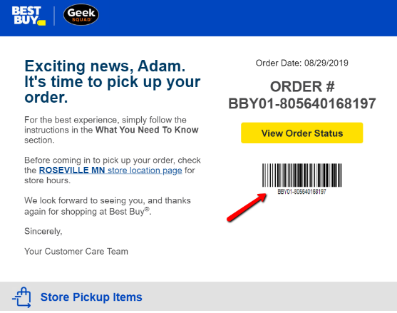
Mai

Vocabulary matching:
electronics (n.) easy to do; easy to use; easy to go to
convenient (adj.) feeling too much at once, confused
overwhelmed (n.) TVs, DVD players, computers, tablets, speakers, etc.
criteria (n.) 3 digit number on the back of debit & credit cards; for security
CVC number (n.) reminder of a choice or action, especially after making an appointment or buying something
confirmation (n.) options/choices available when choosing to do or buy something

Discussion:
- Why did they decide to shop online? Do you think that was a good decision? Why or why not?
- What is in-store pick up? What does that mean?
- Have you ever bought any electronics online? What did you buy? What website did you use?
- Who paid for the TV in the story? Do you think they will split the cost? Do you think Thao will pay Mai back for his half? How much does he owe her?
Partner Activity in the Learning Lab:
- Go to: bestbuy.com
- Click on TVs on their homepage
- Use the menu on the left side to make the same choices that Mai and Thao did:
Store Pickup at the Roseville Best Buy store
Price: $300 maximum
TV Screen Size: 40-43 inches
Customer rating: 4 stars or more
Resolution: 1080p - Full HD
- Choose one TV that meets all their criteria.
- Use your phone to take a picture of that TV on your computer screen.
- Email that picture to Adam: hubbsadam@gmail.com
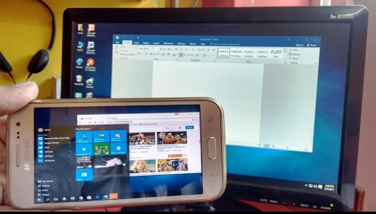
- Tell Adam after you’ve emailed it.

