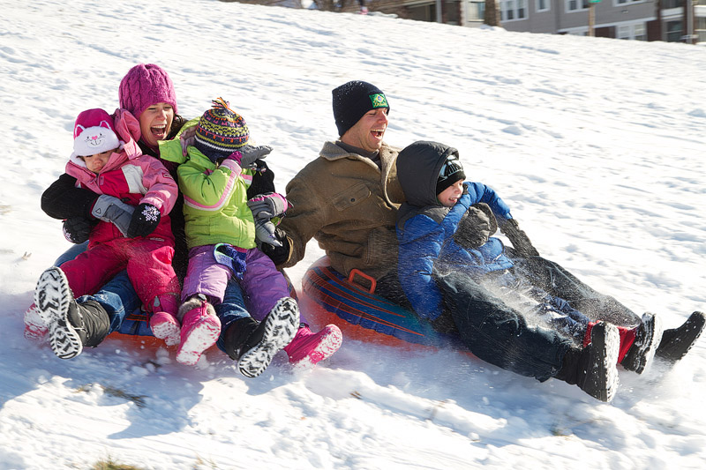
1. Where did this family go to sled?
2. When did they go?
3. Why did they go to sled?
5. Do you think they are having fun?
6. What did they wear?
8. What do you think they will do after they’re done?
9. Have you ever gone sledding? Did you enjoy it?
Write as much as you can about this picture for 15-20 minutes.

