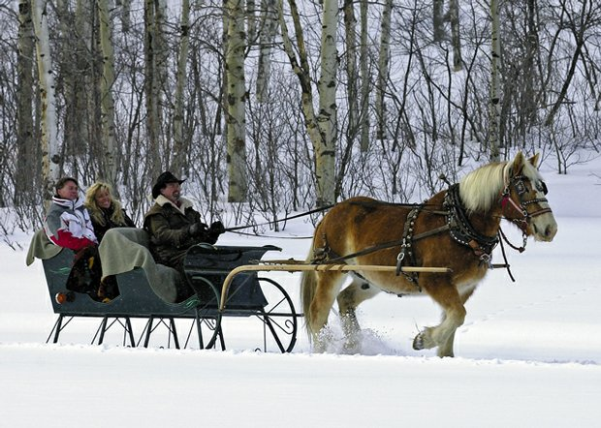
Photo Vocabulary
Nouns: a sleigh, a couple, a man, a driver, a horse, winter, snow, blankets, trees, countryside
Verbs: take a ride, enjoy, ride, pull, drive, travel, wear, use, smile, have fun
Adjectives: happy, strong, young, warm, cold, bright, beautiful, quiet, peaceful
What can you write about what’s happening in this picture?
- __________________________________________________________________________
- __________________________________________________________________________
- __________________________________________________________________________
- __________________________________________________________________________
- __________________________________________________________________________
- __________________________________________________________________________
- __________________________________________________________________________
- __________________________________________________________________________
- __________________________________________________________________________
- __________________________________________________________________________
Directions: Answer the questions below with a complete sentence.
- What are these people doing outside?
__________________________________________________________________________
- How many people are in the sleigh?
__________________________________________________________________________
- What is pulling the sleigh?
__________________________________________________________________________
- How does the couple feel?
__________________________________________________________________________
- What are the people using to stay warm?
__________________________________________________________________________
- Are they in the city?
__________________________________________________________________________
- Are they traveling on a road or through a field?
__________________________________________________________________________
8. Do you think sleigh rides happen more now or in the past?
____________________________________________________________________________
9. What is one winter activity you’ve never tried, but would like to try?
___________________________________________________________________________

Example Sentences

- A man is driving a sleigh.
- These people are having fun.
- This horse is pulling a sleigh.
- This couple is enjoying the weather.
- They are smiling because they are having fun.
- It is cold, so these people are wearing warm clothes.
- It’s cold, so these people are using blankets.

- They are traveling in the countryside.

- The horse is very strong, and it is working hard.

- The driver is holding the reins, and he is wearing a hat.

- It is a beautiful, bright, peaceful day.

- The driver is a strong, young man.

- This couple is taking a sleigh ride because they are on their honeymoon.

- They are having a very fun and relaxing vacation.

