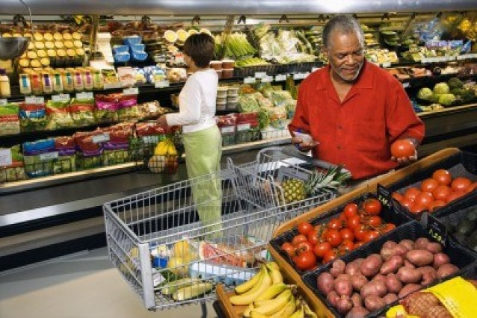

The Smiths Go Shopping
David and Sarah Smith (go, goes, is going) shopping every Saturday morning. They (prefer, prefers, is preferring) to shop for food in their neighborhood. Right now they (shop, shops, are shopping) for fruit and vegetables. Yesterday they (shop, shopped, shops) for yogurt, cheese, meat, bread and eggs. Next weekend they (shop, shopped, will shop) at their favorite grocery store. Shopping (are, is, will be) always something they (enjoys, enjoy, are enjoying) together.
They usually (plans, planned, plan) a menu for the coming week before they (go, going, went) shopping. David (is liking, like, likes) to eat a lot of red meat, like beef and pork, but Sarah (knows, knew, know) that (are, is) not the healthiest choice. So she (is planning, plan, plans) some meals that (is, are, were) vegetarian. Vegetarian (mean, is meaning, means) you (doesn’t, don’t, didn’t) eat meat, but you can still (ate, eat, eating) eggs, milk, cheese and other dairy foods.
Sarah (do, does, is doing) most of the cooking, so David (is saying, say, says,), “As long as it (tasted, tastes, taste) good, I’ll be happy.” Sarah usually (makes, make, maked) a delicious dinner. After dinner, David (cleared, is clearing, clears) the table, (washing, washes, wash) the dishes and (put, puts, is putting) them away.

