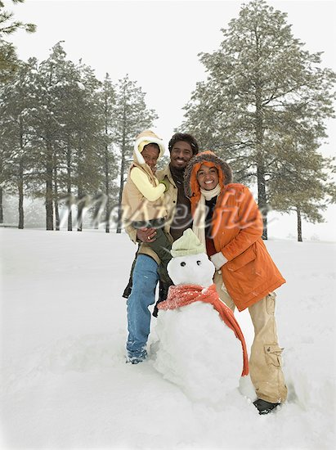
Write as much as you can about this picture.
1. Where did they make this snowman?
2. When did they make it?
3. How long did it take them to build it?
4. Why did they build it?
5. Did they have fun?
6. Who is the dad holding?
7. What did the mom wear?
8. What didn’t the dad wear?
9. What’s the snowman wearing?
10. Who took this picture?
11. Have you ever built a snowman?
12. Do you like being and playing outside in the snow?

Write as much as you can about this picture.
1. Where did they make this snowman?
2. When did they make it?
3. How long did it take them to build it?
4. Why did they build it?
5. Did they have fun?
6. Who is the dad holding?
7. What did the mom wear?
8. What didn’t the dad wear?
9. What’s the snowman wearing?
10. Who took this picture?
11. Have you ever built a snowman?
12. Do you like being and playing outside in the snow?

