The Common Cold (Marshall ABE, Level 3.5)
Colds are very common. Most ______________ have about three colds a year. Children may have more. Colds are caused by cold _____________. Germs are very tiny. They are so tiny that you _______________ see them.
When people with colds _____________ or cough, they spread cold germs. Many people cough and sneeze into their hands. Those cold germs ____________ in the hands. The cold germs are then passed to everything and everyone people _________.
How can you keep from getting a cold? ____________ your hands! Colds are often spread through hand-to-mouth contact. Hand washing can help you from getting or giving cold ___________. Being well-rested will help you stay healthy. Sleep is very important. Most _______________ suggest seven to eight hours of sleep a night. Exercising and eating _______________ foods will also keep colds away. Walk at least 30 minutes a day and eat your fruits and _______________________!
Many who take Vitamin C say they _____________ get as many colds. Oranges, grapefruits and other ____________ fruits have a lot of Vitamin C. Vitamin C is also found in _____________ vegetables and vitamin tablets.
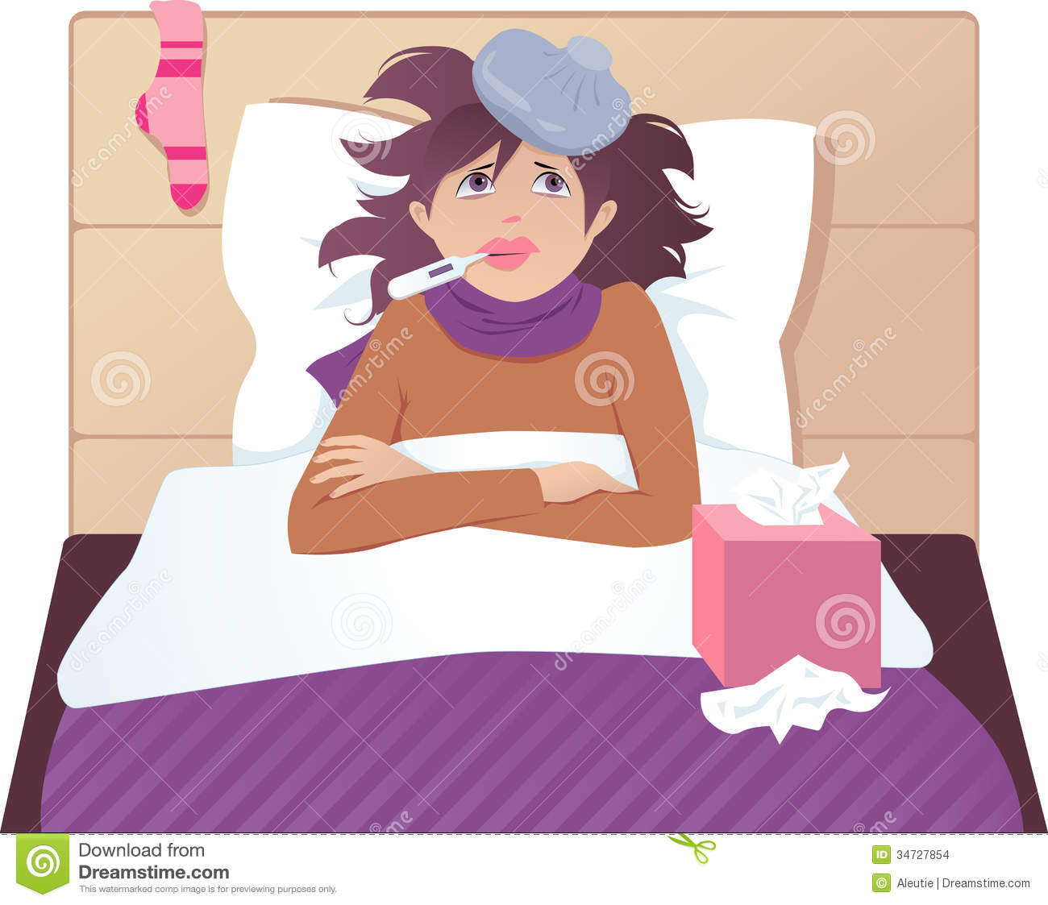

Directions: Read the article The Common Cold. Write a summary of the article. Try to use your own words. Your summary should include the following:

- a topic sentence that states the main idea
- how people catch colds
- what people can do to prevent getting a cold
- what people can do to stay healthy

Summary:

_____________________________________________________________________________________________________________________________________________________________________________________________________________________________________________________________________________________________________________________________________________________________________________________________________________________________________________________________________________________________________________________________________________________________________________________________________________________________________________________________________________________________________________________
_____________________________________________________________________________________________________________________________________________________________________________________________________________________________________________________________________________________________________________________________________________________________________________________________________________________________________________________________________________________________________________________________________________________________________________________________________________________________________________________________________________________________________________________

