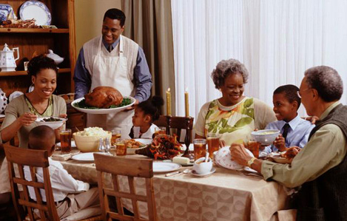
What’s happening in this picture? Where are they? What are they doing? Why are they together? What happened before? What will happen next? Write for 15-20 minutes.

