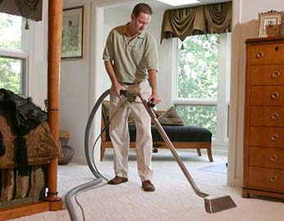
Write these verbs in the blank.
Change them to the simple present tense.
be drive go clean have move vacuum use wash make
put dry are take work

The Carpet Cleaner
This ____ Kevin. He ____ a carpet cleaner. He ________ a van. He _______ to people’s homes and ________ their carpets. First he ______ to move all the furniture out of the room. Next, he __________ the carpet. Then he _______ a special vacuum to wash the carpet. It ________ the carpet wet. The he ______ a big fan on the carpet to dry it. Finally, he ___________ the carpet again. When it ___ dry, he can move the furniture back into the room. It ____ a tough job. Sometimes his back and arms _____ sore. He usually ________ a break while the carpet is _________. He ________ by himself. In the summer, his son John _________ with him. It ____ easier when two people ________ together.
Write these verbs in the blank.
Change them to the simple present tense.

is drive go clean have move vacuum use wash make
put dry are take work

The Carpet Cleaner
This ____ Kevin. He ____ a carpet cleaner. He ________ a van. He _______ to people’s homes and ________ their carpets. First he ______ to move all the furniture out of the room. Next, he __________ the carpet. Then he _______ a special vacuum to wash the carpet. It ________ the carpet wet. The he ______ a big fan on the carpet to dry it. Finally, he ___________ the carpet again. When it ___ dry, he can move the furniture back into the room. It ____ a tough job. Sometimes his back and arms _____ sore. He usually ________ a break while the carpet is _________. He ________ by himself. In the summer, his son John _________ with him. It ____ easier when two people ________ together.

