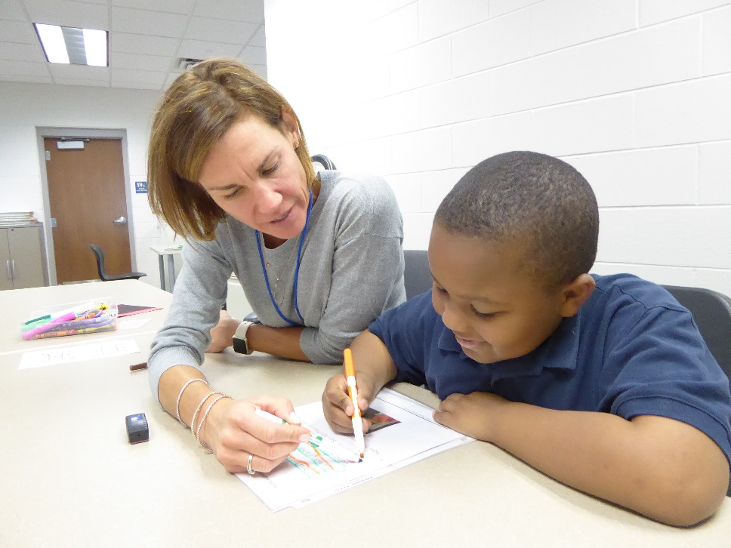
Look at this picture. Write a short story about this person and their job. Then write 7 yes/no questions that you can answer with your story. Write three more Wh-questions (who, what, where, when, why, how).

_____________________________________________________________________________________________________________________________________________________________________________________________________________________________________________________________________________________________________________________________________________________________________________________________________________________________________________________________________________________________________________________________________________________________________________________________________
1.
2.
3.
4.
5.
6.
7.
1.
2.
3.

