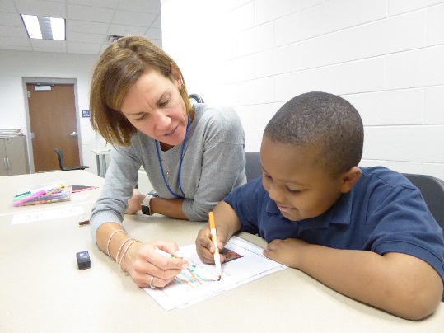
Yes/No Questions: Correct these questions.
1. Does she helping kids? ________________________________
2. Does Semira likes her job? _____________________________
3. Does the boy has many friends? _______________________
______________________________________________________
4. Do she love the boy? ___________________________________
5. Does she a teacher? _________________________________________
6. Does she sitting next to the boy? __________________________________________________
7. Does she working at a school? ____________________________________________________
8. Does the boy writing an essay? ___________________________________________________
9. Does she easy her work? ________________________________________________________
10. is she a teacher ___________________________________________________
11. is she teaching a math _____________________________________________
12. does she helped him _______________________________________________
13. Is little boy learn English. ______________________________________________________
14. Is she has a good Job? __________________________________________
15. Does she starts 8:00? ___________________________________________
16. Does her hair long. ___________________________________________
17. Does the boy wearing t-short? __________________________________________
18. Does he looks like happy? _____________________________________________
19. Is they sitting down? _____________________________________
20. Does they has to finish soon. ______________________________________
Correct or incorrect?
1. Is she a nice teacher? correct incorrect 2. Does Mary works full time? correct incorrect
3. Does she always help her students? correct incorrect 4. Is he often tired? correct incorrect
5. Is he trying to fix his homework? correct incorrect 6. Does she help him? correct incorrect
7. Do they usually work after school? correct incorrect 8. Is she teach him? correct incorrect

