What is the Winter Solstice?
Humans have watched the stars and planets for thousands of years. We use events in the sky to mark time, like seasons. On December 21 or 22 every year, the winter solstice happens. Many people celebrate holidays around this time, like Christmas, Hanukkah and Kwanzaa.
For the northern part of Earth, the winter solstice is the shortest day of the year. Over a year, the days between June and December slowly grow shorter. The sun rises later and sets at an earlier time. Then, winter is dark. This pattern changes at the Winter Solstice. This is when the northern part of Earth is the furthest away from the sun. After the solstice, the days begin to get longer and the nights shorter.
But What Is The Solstice Exactly?
On maps, you might often see some imaginary lines drawn on Earth. These lines help people get measure distance, travel, and also measure time. The equator is an imaginary line drawn right around Earth’s middle. It looks like a belt. It divides Earth into the Northern Hemisphere and the Southern Hemisphere. Another imaginary line drawn through Earth is its axis of rotation. The axis of rotation is a line that connects the North Pole to the South Pole. This line is slightly tilted. As the Earth circles around the sun, the sun's light hits different places at different times. This tilt causes Earth’s changing seasons.
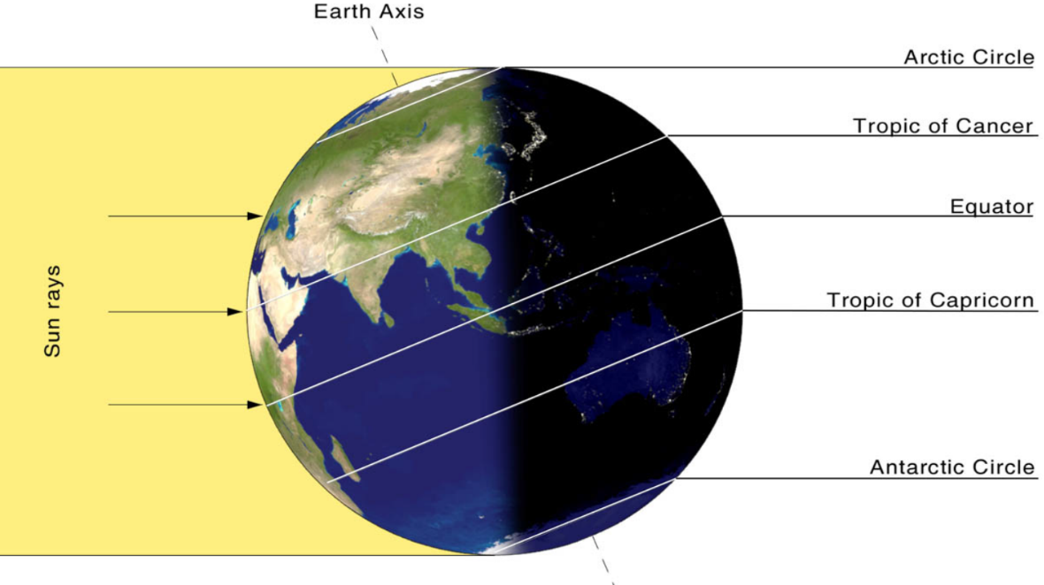
Other useful imaginary lines around Earth are called lines of latitude. They are numbered from 0 degrees to 90 degrees. The one at 0 degrees is the equator. You may have noticed two special lines of latitude on a globe of the world: One in the Northern Hemisphere called the Tropic of Cancer. The other one in the Southern Hemisphere called the Tropic of Capricorn.

Once a year, at noon, the sun is directly overhead these latitudes. In the Northern Hemisphere, on Tropic of Cancer, that is the summer solstice. On the Tropic of Capricorn, that is the winter solstice. The summer solstice has the most hours sunlight of any day. The winter solstice has the fewest.
Who Came Up With The Name Tropic of Cancer?
These names were thought up about 2,000 years ago. At that time, on the summer solstice, people noticed the sun was facing a group of stars called Cancer. However, the sun no longer points toward Cancer. Earth’s axis wobbles a bit. It is always slowly changing the direction in which it points.
The word "tropic" itself comes from the Greek word tropi, meaning "turn." That's because the sun appears to "turn back" at the solstices. When the Tropic of Capricorn was named, the sun was in a group of stars called Capricorn at the winter solstice. Two other major lines of latitude are the Arctic Circle, around the North Pole, and the Antarctic Circle, around the South Pole. On the Arctic Circle, the sun does not set at all on the summer solstice. On that one day, the sun traces a complete circle just above the horizon as the Earth rotates. On the Antarctic Circle, the sun does not set at all on the winter solstice.
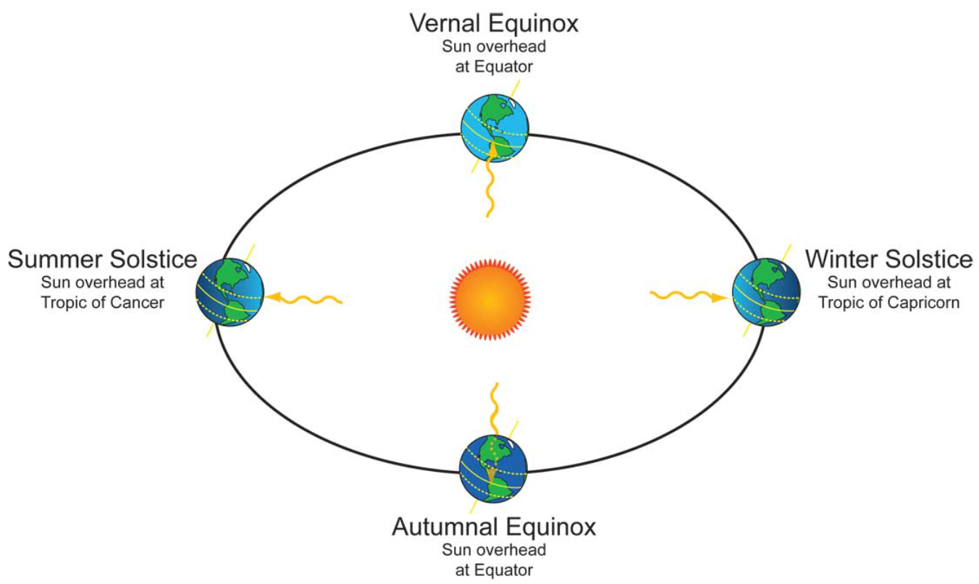
Is The Summer Solstice Also The Hottest Day Of The Year?
The summer solstice is the longest day of the year in the Northern Hemisphere. That part of Earth receives more sunlight than on any other day. Then shouldn’t that day be the hottest? Actually, the hottest days are usually in July and August. The Northern Hemisphere is absorbing lots of sunlight on the summer solstice. It goes into the air and water. It just takes a few weeks for that energy to release.

- Read the following paragraph from the article:
In the Arctic Circle, the sun does not set at all on the summer solstice. On that one day, the sun traces a complete circle just above the horizon as the Earth rotates. On the Antarctic Circle, the sun does not set at all on the winter solstice.
What conclusion can be drawn from the paragraph?
(A) The sun does not set in the winter in the Antarctic Circle.
(B) The sun only shines on the Arctic Circle during the summer.
(C) The same event happens on the summer and winter solstices but in different locations.
(D) The entire Earth receives more sunlight in the summer because of it’s rotation.

- Which sentence from the section "But What Is The Solstice Exactly?" BEST helps the reader understand what causes the solstices?
(A) The equator is an imaginary line drawn right around Earth’s middle.
(B) As the Earth circles around the sun, the sun's light hits different places.
(C) This tilt causes Earth’s changing seasons.
(D) Once per year, at noon, the sun is directly overhead these latitudes.

- Look at the 2nd graphic above. What does it show?
(A) the relationship between the Earth and the sun during the solstices
(B) the two times each year that the sun is directly above the equator
(C) the way the Earth's latitudes change based on the direction of the sun
(D) the length of days at the Tropic of Capricorn compared to the Tropic of Cancer

- The summer solstice has the _________ hours sunlight of any day. The winter solstice has the _______________.

- In the northern hemisphere, the hottest day of the year is the summer solstice. T F

- Titled means ‘upright’ or ‘straight up and down’. T F

