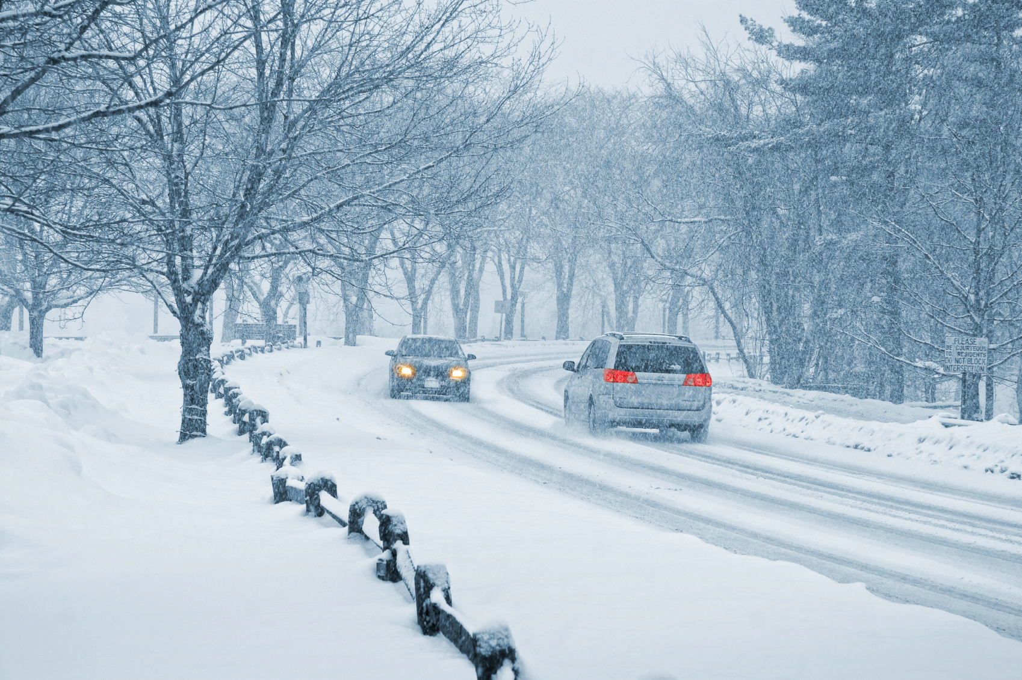
December Reading Assessment Score: /10
Name: ______________________________

Winter Driving
Joe has a long drive to work. He lives in Walnut Grove
and works in Marshall. He drives 30 miles one way. Most spring, summer and fall days he enjoys the drive. Winter driving is different. He does not like to drive in winter weather, but he must get to work.
Over the years, Joe has learned many things about winter driving. He drives with his headlights on all of the time. He also washes them often to keep the lights bright. Joe wants to see and be seen by other drivers.
He tries to keep snow, ice and frost off of his car. Before driving he brushes snow off the hood, lights, mirrors and all of the windows. He also scrapes any ice off those areas.
Joe knows that ice and snow can make roads very slippery. He does not follow cars too closely. Ice and snow can increase stopping distance from three to ten times.
He takes turns very slowly. They can become very icy from the slipping and sliding of many car tires. He has learned to brake before coming to a curve, not while he is in it. Joey is a cautious driver on winter roads. He wants to get to work safely.
1. What is the main idea of this reading?
a. Driving in the winter is dangerous.
b. There are many things you can do to drive more carefully in the winter.
c. Joe doesn’t like winter driving.

2. Which detail in the reading supports the idea that you need to prepare the OUTSIDE of your car for winter driving?
a. Joe does not follow cars too closely.
b. He has learned to brake before coming to a curve.
c. He brushes off his lights often to keep them clear of snow and ice.

3. Which detail in the reading supports the idea that you need to learn different driving skills in the winter?
a. Joe does not follow cars too closely.
b. He scrapes ice off of his windows.
c. He doesn’t like driving in the winter.

4. What would be another good title for this reading?
a. Joe’s Commute to Work
b. Joe Drives Safely in the Winter
c. Winter Driving is Horrible

5. What is the purpose of this reading?
a. To explain different things you can do to drive more safely in the winter.
b. To tell about how Joe drives to work in the winter.
c. To convince people to stay off the roads in the winter.

6. What does “cautious” mean?
a. slow
b. slippery
c. careful

7. What word means the same as “curve?”
a. part of a turn
b. straight ahead
c. really fast

8. In dry road conditions, it takes a car 45 feet to come to a stop when driving 30 mph. If the stopping distance on an icy road is 5 times more, how many feet does it take to stop?
a. 50 feet
b. 225 feet
c. 30 feet

9. Why is it a good idea to brake BEFORE coming to a turn in the winter?
a. So that you can see other drivers and be seen by them
b. Because you shouldn’t follow cars too closely
c. Because it is difficult to control your car while turning and braking on an icy road.

10. What does “scrape” mean?
a. To remove ice from the window with a tool.
b. To wash the headlights with a rag.
c. To brake before a curve on the road.

