Writing 1 November Practice Assessment Name: _________________________
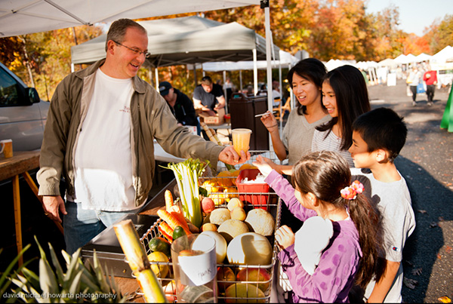
Part 1: Answer the questions with complete sentences.
1. Where are these people? _______________________________________________________
2. What are they buying? ________________________________________________________
3. Who is the seller? ____________________________________________________________
4. How much do you think the juice cost? ___________________________________________
5. Do you think they will pay with cash or a credit card?
_____________________________________________________________________________
6. How often do you think this market happens?
_____________________________________________________________________________
7. What time do you think they will close the market?
_____________________________________________________________________________
Part 2: Finish these sentences with these verbs. Change them to the correct verb tense.
be look wake up sell
8. The family _____________________________ at the juice right now.
9. The man _______________ happy to have customers.
10. There ______________ many tents and vendors at this market.
11. The man _______________ produce here every weekend.
12. The man __________________ early this morning to bring his food to the market.
13. The little girl _________ never ___________ to a farmer’s market before.
Part 3: Write 5 or more sentences about this picture. Use 4 or more verb tenses.

