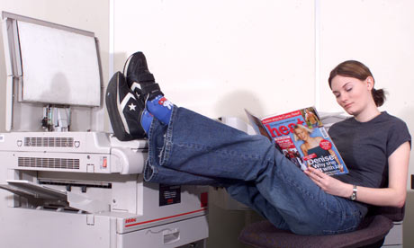
Part 1: Choose the correct verb from the chart below to complete each of the following sentences. Change the verb tense to match the sentence.
violate =  go against/break | perform (negative) | argue
warn | fire = no job | be (negative)
wear | read | need

1. Lisa ______________________ a good worker.
2. In this photo, she _________________________ instead of doing her work.
3. Lisa often ________________________ her company’s clothing regulations. She should wear business clothing, but she usually _____________ jeans and tennis shoes.
4. Lisa usually ___________________________________ her duties as an office assistant.

5. Recently, she ______________________ with her co-workers about an email she sent.
6. Last week, the manager ___________________________ Lisa about her unacceptable behavior.
7. I think that the manager ____________________________ her later today.

8. Lisa ______________ to think about how important it is to care about her job.


Luisa

Part 2: Look at the picture and answer the questions below. Make sure to use complete sentences. Here are some verbs to help you: prepare, cut, clean, wash, serve, wear, cook, talk, learn, is, etc.

1. Where is Luisa?

2. What did Luisa do a few minutes ago?

3. Do you think she is hardworking or lazy?

4. What work clothes is she wearing?

5. What is she doing right now?

_________________________________________________________________________
6. What do you think she enjoys doing at work?

_________________________________________________________________________
7. How often do you think her supervisor evaluates her work?

_________________________________________________________________________
8. Do you think Luisa will wear gloves when she cooks at home tonight?

_________________________________________________________________________

